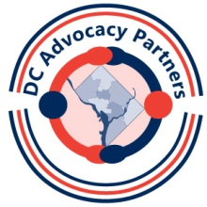
Long Term Project Reference Guide
In Sept you will present results of your long term project. The project should be something that makes a change in the lives of people with disabilities in DC. It is your opportunity to pursue an area of interest. You will have a guidance from DC AP staff (and fellow Partners) along the way!
The first step is to pick a project to work on.
- Something that can be completed in about 7 months OR
- Something that is the first part of a larger project (but has some goals that can be achieved in 7 months) OR
- Something that is the next step in work you are already doing
Sample project ideas:
- Work with your church leaders to improve physical or cultural accessibility
- Organize an inclusive group, e.g. bowling team, book club, exercise program, etc.
- Work on a disability platform for a local political candidate
- Work with schools to improve transition planning for students with disabilities
- Map all accessible recreation opportunities, literacy programs, or other area in DC
- Work with a local playground (or daycare provider or apartment complex) to make it accessible
- Work with Metro to publicize their orientation program for riders with disabilities
- Develop an emergency plan for your work site or apartment building that includes the needs of people with disabilities
- Work with your job to set up a summer work experience for youth with disability
- Work with your medical provider to help make the facility accessible

What we don’t want: a research paper or presentation on an area of interest. You should go out in your community to make this project a success!

In thinking about the possible topic for a project, try to answer these questions:
- If all goes well, what will the outcome be?
- What will have changed?
- Who will benefit from this change?
- What should you do first to get started?

