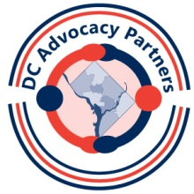
2014 Session 2 – Community Involvement Hand-In Sheet
You will hand in this sheet at the March session (or you can e-mail it in advance to finkd@iel.org) Please answer Part One & Part Two
Part One: Answer the questions below for one or more resources in your packet
Which resource(s) did you find helpful?
______________________________________________________________________________________
How do you think you will use this information?
__________________________________________________________________________________________________________________________________________________________________________________________________________________________________________________________________
Part Two: Answer the questions below for TWO letter choices from Part Two
Which letter did you choose and what did you do? ______________________________________________________________________________________
What did you learn from this? __________________________________________________________________________________________________________________________________________________________________________________________________________________________________________________________________
Which other letter did you choose and what did you do?
______________________________________________________________________________________
What did you learn from this? __________________________________________________________________________________________________________________________________________________________________________________________________________________________________________________________________

