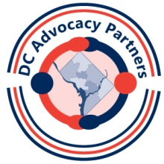
Community Involvement Guide
The purpose of Community Involvement work is to introduce you to events in the DC area that focus on disability issues. Each month you will be asked to get involved in your local community and national events that are taking place here in DC.
Why? Because as you learn more about influencing policy you will learn how to be a part of the public policy decision-making process first-hand. You will find out what is happening in a variety of areas and you will be asked to be there. In some cases you may be an observer; in other cases you may take an active role. We’ll show you how.
Each month you will get a questions to answer about the activities in which you participated. This will become a part of your advocacy resume: your list of what you have accomplished in 2015 on both the local and national levels.
There will be three sections to the Community Involvement work.
- Use Your Resources: An in-depth look at this month’s resources, found in your resource packet. This serves as a review from the session
- Explore the Community: Organizations to learn more about and opportunities to attend events around town

- Prepare for What’s Ahead: Resources to prepare for the next month’s topic

You will be given several options within each section so that you can choose activities that are of interest to you. You can either email in your answers to Dana or bring them to the next class session.

Anytime you have any questions or need any assistance, please call or email Dana
(202.822.8405x132) finkd@iel.org, Frances (202.822.8405x121) Sherri (703.532.4843)
coles.sherri@gmail.com, or Suzanne (703.241.0386) suzanneripley@gmail.com.

We are always available to help you.

