DC AP Table of Contents:
Disability History

Table of Contents | Pages
Session One Agenda | 2
Objectives: Competencies & Skill-Sets | 3
Homework: Community Involvement | 4 – 5
Homework Sheet | 6 - 7
Chart of DC Resources | 8 – 24
The Disabilities Context | 25 - 47
Self-Determination | 48 – 49
Rights of People with I/DD | 50
Article: People First Language | 51 - 54
Identity First Language | 55
Article: Why I dislike “person first language” | 56 - 57
Article: Iron Triangle | 58 – 64
Americans with Disabilities Act with Q&A | 65 – 85
Outside Events for Community Involvement | 86
Biographies | 87 - 91

Session 1 Agenda: Disability History

Date & Time: Friday, May 31, 2019 12PM – 8PM
Location: 4301 Connecticut Avenue NW, Suite 100

Time | Topic
12:00 PM – 12:45 PM | Working Lunch, Welcome & Introductions  (Carly Fahey, Jessica Fuentes-Diaz)
12:45 PM - 1:00 PM | Break
1:00 PM – 1:50 PM | Alumni Panel
1:50 PM – 2:40 PM | Speaker/Activity & Discussion  (Taryn Williams, ODEP)
2:40 PM – 3:10 PM | Power of 504 Video
3:10 PM – 3:25 PM | Break
3:25 PM – 4:10 PM | Language Activity
4:10 PM – 4:40 PM | FAQs on the Americans with Disabilities Act
5:00 PM – 6:00 PM | Dinner
6:00 PM – 6:40 PM | Iron Triangle Activity
6:40 PM – 7:10 PM | Requirements: Homework Community Involvement & Long-term Project Discussion
7:10 PM – 7:40 PM | Resources Review
7:00 PM – 7:30 PM | Complete Evaluations & One-on-One Assistance
7:30 PM – 8:00 PM | Close out Activity

Session 1 Objectives –
Competencies & Skill Sets

Competencies
- Partners will begin to develop an understanding of:
- The purpose of the DC Advocacy Partners Program
- The connections among policymakers, policy influencers, and policy implementers
- The history of attitudes and practices toward people with disabilities
- The self-advocacy movement
- The importance and impact of personal stories in providing testimony
- The Americans with Disabilities Act and related legislation

Skill-Sets
- Partners will begin to be able to:
- Use person-first language and other preferred terms to refer to disability
- Feel more comfortable speaking in front of a group of peers
- Recognize who in DC and nationally plays a role in policymaking, policy influencing, and policy implementing
- Recognize who is entitled to rights under the Americans with Disabilities Act

Session 1 Homework – Community Involvement

The purpose of the Community Involvement assignments is to connect the work you are doing in class with the work of the broader disability community, both in DC and nationally. The goal of Community Involvement is to become personally involved in resources and events or meetings or activities in DC, to learn about what is happening and to meet city leaders and other advocates.

Each month, you will be expected to complete three parts to the Community Involvement: 1. Use Your Resources; 2. Explore the Community; 3. Prepare for What’s Ahead. You will be given several options within the Community Involvement so that you can select activities that are of interest to you. You will then answer a few questions about what you did this month and you turn these in at the next session.

If you have any questions or need any assistance, call or email Carly Fahey (202-822-8405 x???) faheyc@iel.org or Jessica Fuentes-Diaz (202-822-8405 x144) fuentesdiazj@iel.org.

There are 3 sections in this assignment. Pick one activity from each of the three sections.
Section 1: Use Your Resources
Review your resource packet by reading through the Partial List of DC Resources on pages 9-33. Answer the Section 1 questions about this resource on the Community Involvement Hand-in Sheet.

Section 2: Explore the Community
Attend one (or more!) events in the community, either one that is listed in the events section on page 133-142 or another relevant community event. Then answer the Section 2 questions about it on the Community Involvement Hand-in Sheet. If you participated in more than one event, please answer the questions below for all.

Session 1 Homework – Community Involvement

Section 3: Prepare for What’s Ahead
Next month’s topic is on Intellectual/Developmental Disabilities in the 21st Century and Service Coordination which covers a broad range of topics. Pick one of the options below to learn more about in preparation for next month and answer the Section 3 questions about it on the Community Involvement Hand-in Sheet.

- Visit the website for the Administration on Intellectual and Developmental Disabilities http://www.acl.gov/Programs/AIDD/DD_History/index.aspx to read the definition of who is covered under the Developmental Disabilities Act (DD Act) (under the section titled Background and Expanding Eligibility). Think about the definition of who is covered under the Americans with Disabilities Act we learned about in January and describe how the DD Act definition is similar and different.

- Visit the website for the Administration on Intellectual and Developmental Disabilities http://www.acl.gov/Programs/AIDD/DD_History/index.aspx to read about the programs established by the Developmental Disabilities Act (DD Act). What are the six programs? How can you find out which organizations house these programs in DC?

- Visit the DC Department on Disability Services website to find out what Service Coordination is http://dds.dc.gov/page/service-coordination. What is one way that DC tries to provide unique services for each person with a disability’s individual needs?

Session 1 Homework – Community Involvement

Homework Sheet
You will hand in this form at Session 2 on Friday, June 28, 2019.

NAME:
DATE:
Please write up the answers to the questions you have selected. This must be handed in at the next DC AP session - Friday, June 28.
If you have any questions or need any assistance, call or email Carly Fahey (202-822-8405 x???) faheyc@iel.org or Jessica Fuentes-Diaz (202-822-8405 x144) fuentesdiazj@iel.org.

Section 1. Respond to ONE of the two questions below
- Which City Councilmember represents your ward?

Which committees does your City Councilmember serve on?

2. Review the list of DC disability focused organizations and agencies.

Do you already belong to one or more of these (or to one that is not on this list)?
Yes or No?

Name them:

Which one(s) are of interest to you?

Section 2.
- Which community event or activity did you visit or attend?

- Was it interesting to you? Yes or No?
Why or why not?

- What did you learn from this?

- What did you want or expect to learn that wasn’t covered?

Section 3.

  - Which option did you select? A, B, or C?

  - Depending on the option you selected, answer the related question below:

- Who is covered under the DD Act?

- List the six programs of the DD Act:

- What is Person Centered Planning?

Chart of DC Resources

There are a variety of disability organizations, agencies and groups in DC. Most offer information and referral services, specialized training, advocacy alerts, information on upcoming DC legislative decisions, newsletters and more. Most services are available free of charge. You may find additional organizations. If you do, please let us know so we can add them to this list.

Offices of the Mayor and City Council Members
D.C. City Council
Thirteen Members make up the D.C. City Council: a representative elected from each of the eight wards, and five members, including the Chair, elected at-large. As the central and chief policy-making body for the District of Columbia, the Council’s mission is to provide strong, innovative and effective leadership for the benefit of residents across the city. The Council’s central role as a legislative body is to make laws. However, its responsibilities also include oversight of multiple agencies, commissions, boards and other instruments of District government.
Address: 1350 Pennsylvania Avenue, NW, Washington, DC 20004
Website: http://www.dccouncil.us
Phone: 202-724-8000
Email: dccouncil@dccouncil.us

DC Councilmembers
Phil Mendelson (Chairman)
Chairs: Committee of the Whole Committees: Committee of the Whole
1350 Pennsylvania Avenue, NW, Suite 504, Washington, DC 20004 http://www.dccouncil.us/council/phil-mendelson http://chairmanmendelson.com
202-724-8032 pmendelson@dccouncil.us

Anita Bonds (At-Large)
Chairs: Housing and Community Development
Committees: Education; Houing and Community Development; Judiciary; Committee of the Whole
1350 Pennsylvania Avenue, NW, Suite 110, Washington, DC 20004 http://www.dccouncil.us/council/anita-bonds
202-724-8064 abonds@dccouncil.us
David Grosso (At-Large)
Chair: Committee on Education
Committees: Education; Finance and Revenue; Health and Human Services; Committee of the Whole
1350 Pennsylvania Avenue, NW, Suite 402, Washington, DC 20004 http://www.dccouncil.us/council/david-grosso
http://david-grosso.tumblr.com/
202-724-8105 dgrosso@dccouncil.us

Elissa Silverman (At-Large)
Committee: Business, Consumer and Regulatory Affairs, Housing and Community Development, Finance and Revenue, Committee of the Whole
1350 Pennsylvania Avenue, Suite 408 NW, Washington, DC 20004
http://dccouncil.us/council/elissa-silverman http://www.elissasilverman.com
202-724-7772 esilverman@dccouncil.us

Robert R. White (At-Large)
Chairs: Committee on Facilities and Procurement
Committee: Committee of the Whole, Committee on Finance and Revenue, Committee on Education, Committee on Housing and Neighborhood Revitalization, Committee on Human Services, Committee on Labor and Workforce Development
1350 Pennsylvania Avenue NW Suite 107, Washington, DC 20004
https://dccouncil.us/council/councilmember-robert-c-white-jr/ http://www.RobertWhiteAtLarge.com
202-724-8174 rwhite@dccouncil.us

Brianne Nadeau (Ward 1)
Committees: Business, Consumer and Regulatory Affairs; Health and Human Services; Housing and Community Development; Committee of the Whole 1350 Pennsylvania Avenue, NW, Suite 105, Washington, DC 20004 http://www.dccouncil.us/council/brianne-nadeau http://www.brianneknadeau.com
202-724-8181 bnadeau@dccouncil.us

Jack Evans (Ward 2)
Chairs: Committee on Finance and Revenue
Committees: Finance and Revenue; Judiciary; Transportation and the Environment; Committee of the Whole
1350 Pennsylvania Avenue, NW, Suite 106, Washington, DC 20004 http://www.dccouncil.us/council/jack-evans http://www.jackevans.org
202-724-8058 jevans@dccouncil.us

Mary M. Cheh (Ward 3)
Chairs: Committee on Transportation and the Environment
Committees: Transportation and the Environment; Judiciary; Health and Human Services; Committee of the Whole
1350 Pennsylvania Avenue, NW, Suite 108, Washington, DC 20004 http://www.dccouncil.us/council/mary-m.-cheh http://www.marycheh.com
202-724-8062 mcheh@dccouncil.us

Brandon T. Todd (Ward 4)
Committees: Business, Consumer, and Regulatory Affairs; Education; Transportation and the Environment; Committee of the Whole 1350 Pennsylvania Avenue, NW, Suite 105, Washington, DC 20004 http://www.dccouncil.us/council/brandon-todd
202-724-8052
btodd@dccouncil.us

Kenyan McDuffie (Chair Pro Tempore, Ward 5)
Chairs: Committee on the Judiciary
Committees: Judiciary; Finance and Revenue; Transportation and the Environment; Committee of the Whole
1350 Pennsylvania Avenue, NW, Suite 506, Washington, DC 20004 http://www.dccouncil.us/council/kenyan-mcduffie http://www.kenyanmcduffie.com
202-724-8028 kmcduffie@dccouncil.us

Charles Allen (Ward 6)
Committees: Education; Transportation and the Environment; Business, Consumer and Regulatory Affairs; Committee of the Whole
1350 Pennsylvania Avenue, NW, Suite 406, Washington, DC 20004 http://www.dccouncil.us/council/charles-allen http://www.charlesallenward6.com
202-724-8072 callen@dcouncil.us

Vincent Gray (Ward 7)
Chair: Committee on Health
Committee: Committee of the Whole, Committee on Business and Economic Development, Committee on Finance and Revenue, Committee on the Judiciary and Public Safety
1350 Pennsylvania Avenue NW, Suite 406, Washington, DC 20004
https://dccouncil.us/council/vincent-gray/
202-724-8068 vgray@dccouncil.us

Trayon T. White (Ward 8)
Chair: Committee on Recreation and Youth Affairs
Committee: Committee of the Whole Committee on Education, Committee on Government Operations, Committee on Housing and Neighborhood Revitalization, Committee on Labor and Workforce Development
1350 Pennsylvania Avenue NW, Suite 400, Washington, DC 20004
https://dccouncil.us/council/councilmember-trayon-white-sr/ http://www.trayonwhite8.com
202-724-8045 twhite@dccouncil.us

Executive Office of the Mayor, Muriel Bowser
Address: 1350 Pennsylvania Avenue, NW, Suite 316, Washington, DC 20004
Website: http://mayor.dc.gov Email: eom@dc.gov
Phone: 202-727-2643 TTY: 711

D.C. Government Departments and Agencies
Office of the State Superintendent of Education, DC.
The Office of the State Superintendent of Education (OSSE), formerly known as the State Education Office (SEO) sets policies, exercises oversight, and directs resources that guarantee residents educated in the District of Columbia are among the highest performers in the nation, fully prepared for successful postsecondary learning and employment in the creative economy. As the State Education Agency for DC, the OSSE sets statewide policies, provides resources and support, and exercises accountability for all public education in DC.
Address: 1050 First Street, NE, Washington, DC 20002
Website: http://osse.dc.gov Email: osse@dc.gov
Phone: 202-727-6436 TTY: 711

D.C. Department of Employment Services – American Job Centers
D.C. Department of Employment Services (DOES) provides job seekers with a number of employment opportunities. Each center provides career counseling, career planning, resume assistance, direct job placement, classroom and on-the-job training, access to America's Job Bank (both online and via telephone), information about local and national labor markets, unemployment compensation and much more. Customers interested in additional services should go to one of the full service one-stop centers listed below.
Address: 4058 Minnesota Avenue, NE, Washington, DC 20019 (Headquarters)
Website: http://does.dc.gov/ Email: does@dc.gov
Phone: 202-724-7000 TTY: 202-698-4817

Individual American Job Centers:
American Job Center — Headquarters
4058 Minnesota Avenue, NE, Washington, DC 20019
202-724-2337 202-698-4817 (TTY)

American Job Center – Northeast
CCDC – Bertie Backus Campus, 5171 South Dakota Avenue, NE, Washington, DC 20017
202-576-3092 202-576-3102 (TTY)

American Job Center – Northwest
Frank D. Reeves Municipal Center, 2000 14th Street, NW, 3rd Floor, Washington, DC 20009
202-442-4577 202-481-3451 (TTY)

American Job Center – Southeast
3720 Martin Luther King, Jr. Avenue, SE, Washington, DC 20032
202-741-7747 202-481-3920 (TTY)

D.C. Department on Disability Services
The purpose of the Department on Disability Services (DDS) is to provide innovative high quality services that enable people with disabilities to lead meaningful and productive lives as vital members of their families, schools, workplaces and communities in every neighborhood in the District of Columbia. DDS is the lead District agency assisting residents with disabilities, including people with Intellectual and Developmental Disabilities and their families. DDS has two administrations: the Developmental Disabilities Administration (DDA) and the Rehabilitation Services Administration (RSA).
Address: 250 E Street, SW, Washington, DC 20024
Website: http://dds.dc.gov Email: dds@dc.gov
Phone: 202-730-1700

Developmental Disabilities Administration
The Developmental Disabilities Administration (DDA) is the public agency responsible for the oversight and coordination of all services and supports provided to qualified persons with intellectual disabilities in the District of Columbia. DDA supports individuals with intellectual disabilities to have the most independence and choice and control over their own lives through person-centered service planning and delivery and increased provider capacity. DDA coordinates home and community services for over 2,000 individuals so each person can live and work in the neighborhood of his or her choosing, and promotes health, wellness and a high quality of life through service coordination and monitoring, clinical supports, and a robust quality management program.
Address: 1125 15th Street, NW, Washington, DC 20005
Website: http://dds.dc.gov/service/services-people-idd Email: dds@dc.gov
Phone: 202-730-1700 202-730-1516 (TTY)

Rehabilitation Services Administration
The Rehabilitation Services Administration (RSA) provides quality comprehensive vocational rehabilitation (VR) and independent living services to eligible individuals with disabilities. RSA services, which include job counseling, development, placement, and retention, assist consumers to prepare for, obtain, and maintain competitive employment. RSA markets the placement of its consumers in high growth and high demand employment to improve their independence and self sufficiency.
Address: 1125 15th Street, NW, Washington, DC 20005
Website: http://dds.dc.gov/service/vocational-rehabilitation-services-rsa Email: dds@dc.gov
Phone: 202-442-8400 (RSA) or 202-730-1700 (DDS); 202-730-1516 (TTY)

D.C. State Development Disability Council
The D.C. State Developmental Disabilities Council (DDC) promotes and engages in systems or process changes, capacity building and advocacy activities. All are designed to achieve independence, productivity, integration and community inclusion of individuals with intellectual and developmental disabilities.
Address: 441 4th Street, NW, Suite 729 North, Washington, DC 20001
Website: http://ddc.dc.gov Phone: 202-724-8612; 711 (TTY)

D.C. Office of Disability Rights
The mission of the D.C. Office of Disability Rights (ODR) is to ensure that the programs, services, benefits, activities and facilities operated or funded by the District of Columbia are fully accessible to, and useable by people with disabilities. ODR is committed to inclusion, community-based services, and self-determination for people with disabilities. ODR is responsible for overseeing the implementation of the City's obligations under the Americans with Disabilities Act (ADA), as well as other disability rights laws. DC Commission on Persons with Disabilities is part of the Office of Disability Rights. The Commission is committed to enhancing the image, status, inclusion and quality of life for all District residents, visitors, and employees with disabilities and ensuring that they have the same rights and opportunities as those without disabilities. It serves as an advisory body to the Mayor and the District’s Office of Disability Rights (ODR) as well as other agencies serving people with disabilities.
Address: 441 4th Street, NW, Suite 729 North, Washington, DC 20001
Website: http://odr.dc.gov Email: odr@dc.gov
Phone: 202-724-5055; 202-727-3363 (TTY)
D.C. Department of Behavioral Health
The purpose of the D.C. Department of Behavioral Health (DBH) is to support prevention, resiliency and recovery for District residents in need of public behavioral health services and supports
Address: 64 New York Avenue, NE, 3rd Floor, Washington, DC 20002
Website: http://dbh.dc.gov Email: dbh@dc.gov
Phone: 202-673-7440; 202-673-7500 (TTY)

D.C. Office of the Tenant Advocate
The purpose of the D.C. Office of the Tenant Advocate is to advocate for, educate, and provide outreach for tenants in the District of Columbia.
Address: 2000 14th Street, NW, Suite 300 North, Washington, DC 20009
Website: http://ota.dc.gov Phone: 202-719-6560; 711 (TTY)

D.C. Public Charter Schools
To provide quality public school options for DC students, families, and communities through a comprehensive application review process, effective oversight, meaningful support, and active engagement of its stakeholders. Charter schools are independently operated public schools and serve as their own local education agency (LEA), unless a charter school chooses D.C. Public Schools to be its LEA. The D.C. Public Charter School Board oversees all charter schools.
Address: 3333 14th Street, NW, Suite 210, Washington, DC 20010
Website: http://www.dcpcsb.org Email: dcpublic@dcpcsb.org
Phone: 202-328-2660

D.C. Public Schools
The goal of the District of Columbia Public Schools (DCPS) is to make D.C. the highest- performing urban school district in the nation, and to once and for all close the achievement gap that separates low-income students and students of color from their higher-income and white peers.
Address: 1200 First Street, NE, Washington, DC 20002
Website: http://dcps.dc.gov/DCPS
Phone: 202-442-5885; 711 (TTY)

Some DCPS Offices
Office of Social, Emotional, and Academic Development
Melissa Kim, melissa.kim@k12.dc.gov

Office of Data Systems and Strategy
Colin Taylor (Interim), colin.taylor@k12.dc.gov

Office of Elementary Schools
Angela Chapman, angela.chapman@dc.gov

Office of Equity
Brenda Elliott, brenda.elliott@dc.gov

Office of Family and Public Engagement
Shanita Burney, shanita.burney@dc.gov

Office of Secondary Schools
Shawn Stover (Interim), shawn.stover@dc.gov

Office of Teaching and Learning
Corinne Colgan (Interim), corinne.colgan@dc.gov

Office of Innovation and Systems Improvement
Amy Maisterra (Interim), amy.maisterra@dc.gov

Office of the Chief Business Officer
Sara Goldband, sara.goldband@dc.gov

Office of the Chief Operating Officer
Patrick Davis, patrick.davis@k12.dc.gov

Office of School Design and Continuous Improvement
Gene Pinkard, eugene.pinkard@dc.gov

Office of Talent and Culture
Julie Johnson, julie.johnson@dc.gov

Office of the Chief of Staff
Aiyana Mourtos (Interim), aiyana.mourtos@dc.gov

Office of Integrity
Art Fields, arthur.fields@dc.gov

Office of the General Counsel
Scott Barash, scott.barash@dc.gov

Nonprofit Local Disability Organizations
Advocates for Justice and Education, Inc.
The mission of Advocates for Justice and Education (AJE) is to educate parents, youth, and the community about the laws governing public education, specifically for children with special needs. AJE seeks to empower youth and parents to be effective advocates on behalf of their children to ensure that they receive an appropriate education.
Also, part of Advocates for Justice:
- District of Columbia Parent Information Network (DC PIN)
DC PIN provides children and youth (ages 0-26) with special needs and their families with family navigation, care coordination, community education and individual advocacy.

- DC Behavioral Health Access Project (DC BHAP)
DC BHAP is designed to ensure that early intervention strategies are employed in response to mental health crisis and behavior issues in children; and to ensure that community based supports are in place to support healthy integration into the community, and direct advocacy for services are made available to families in an effort to improve parent engagement and children’s access to appropriate mental health services.

- Parent Training and Resource Center
The Parent Training and Resource Center (PTI) is a comprehensive resource library and training center. The center offers parents information on the laws of special education, specific disabilities, the latest research on treatment and interventions, and adaptive technology.

- Transition Advocacy Project
The Transition Advocacy Project (TAP) provides youth ages 13-26 with support, advocacy, information, and training in order to improve their involvement in their educational planning.

- Family to Family Health Information Centers
Provide information and assistance to children and youth with special health care needs.
Address: 25 E Street, NW, 4th Floor, Washington, DC 20001
Website: http://www.aje-dc.org
Phone: 202-678-8060 or 888-327-8060
Email: Online contact form at http://www.aje-dc.org/contact-forms

Art Enables
Very often people with developmental disabilities are better able to express themselves in images than in words. Art Enables is focused on just such a group: thirty-some artists whose disabilities include but are not limited to Down syndrome, autism, traumatic brain injury, bipolar disorder. Their ages range from 24 to 72. They are African- American, Caucasian, Hispanic, Asian, Arab.
Address: 2204 Rhode Island Avenue, NE, Washington, DC 20018
Website: http://www.art-enables.org Email: info@art-enables.org
Phone: 202-554-9455

The D.C. Center for Independent Living
The D.C. Center for Independent Living, Inc., (DCCIL) is a consumer controlled, cross disability, community based, private non-profit organization that promotes independent life styles for persons with significant disabilities in the District of Columbia.
Address: 2600 12th Street, NE, Washington, DC 20018 (Main Office)
Website: http://www.dccil.org
Phone: 202-338-0033; TTY: (202) 470-1534

D.C. Health Resources Partnership
The goal of the D.C. Health Resources Partnership is to expand the community health care capacity to provide health and mental health services that are accessible to individuals with intellectual and other developmental disabilities, and to implement strategies to promote quality health outcomes for this population.
Address: Georgetown University, Box 571485, Washington, DC 20057
Website: http://gucchd.georgetown.edu Email: gucdc@georgetown.edu
Phone: 202-687-5000

D.C. Partners in Transition
D.C. Partners in Transition is a group of D.C. stakeholders committed to improving the ability of D.C. youth with special needs and disabilities to successfully transition into education, employment, and independence. D.C. Partners is made up of students, young adults, teachers, community organizations, government representatives, employers, parents, and more. Everyone is welcome to join us.
Website: http://www.dctransition.org Email: info@dctransition.org

The HSC Foundation
The HSC Foundation is dedicated to improving access to services for individuals who face social and health care barriers due to disability, chronic illness, or other circumstances that present unique needs.
Address: 2013 H Street, NW, Suite 310, Washington, DC 20006
Website: https://hschealth.org/foundation Email: info@hscfoundation.org
Phone: 202-454-1220

Youth Transitions Collaborative
The Youth Transitions Collaborative has been established to provide expertise and advice on planning, programming, and advocacy for the National Youth Transitions Center. Youth Transitions Collaborative members are vital contributors in the collaborative community which seeks to empower youth and young veterans with disabilities to create a self-directed path to adulthood and employment.
Address: 2013 H Street, NW, Suite 310, Washington, DC 20006
Website: http://thenytc.com

HSC Healthcare System
The HSC Healthcare System believes that children and young adults (birth through age 25) with special needs deserve a level of care that consistently and comprehensively looks out for their best interests. They provide innovative care to the pediatric Supplemental Security Income (SSI) and SSI-eligible populations of Washington, DC, through a management network that coordinates health, social, and education services for our members.
Address: 1101 Vermont Avenue, NW, Suite 1200, Washington, DC 20005
Website: http://www.hscsn-net.org/HSCSN_Home
Phone: 202-467-2737 or 866-937-4549

Inclusion Research Institute
The primary mission of the Inclusion Research Institute (IRI) is to research, develop and disseminate innovations that enable persons of all ages, including individuals with disabilities or other disadvantages, to be independent, productive and included in schools, communities, and places of employment.
Address: 1319 Pennsylvania Avenue, SE, Suite 100, Washington, DC 20003
Website: http://www.inclusionresearch.org/ Email: info@inclusionresearch.org
Phone: 202-338-7158

Quality Trust for Individuals with Disabilities
Quality Trust's vision is a community where everyone is respected, belongs, contributes, is valued and shapes his or her own present and future. Quality Trust's mission is to be an independent catalyst for change in the lives of people of all ages with developmental disabilities. Quality Trust partners with people and their families so they can succeed, thrive and experience full membership in the communities they choose.
Address: 4301 Connecticut Avenue, NW, Suite 310; Washington, DC 20008
Website: http://www.dcqualitytrust.org Email: info@dcqualitytrust.org
Phone: 202-448-1450

Project ACTION!
Project ACTION! is a coalition of self-advocates and self-advocacy groups from the District of Columbia and surrounding areas. ACTION! stands for Advocacy, Change, Training, Information, Organizing, and Networking!
Website: http://www.dcqualitytrust.org/advocates/join-project-action
Phone: 202-448-1458 (Phyllis Holton) Email: pholton@dcqualitytrust.org

Shared Horizons
Shared Horizons is a nonprofit organization created to improve the quality of life for people with disabilities through the Wesley Vinner Memorial Trust, which is a Pooled Special Needs Trust. The mission is to protect the assets belonging to individuals with disabilities while maintaining their eligibility for governmental support programs.
Address: 4301 Connecticut Avenue, NW, Suite 310, Washington, DC 20008
Website: http://www.shared-horizons.org/ Email: info@shared-horizons.org
Phone: 202-448-1460

United Cerebral Palsy of Washington DC & Northern Virginia
United Cerebral Palsy (UCP) of Washington, DC and Northern Virginia serves adults with cerebral palsy and other disabilities. The mission is to advance the independence, productivity and quality of life for individuals with disabilities and their families.
Address: 3135 8th Street, NE, Washington, DC 20017
Website: http://www.ucpdc.org Email: Dawn Carter, dcarter@ucpdc.org
Phone: 202-269-1500

University Center for Excellence in Developmental Disabilities, Georgetown University Center for Child and Human Development
Since 1963, University Centers for Excellence in Developmental Disabilities Education, Research, and Service (UCEDD) have been working to accomplish a shared vision that foresees a nation in which all Americans, including Americans with disabilities, participate fully in their communities.
Address: Georgetown University Center for Child and Human Development, Georgetown University, Box 571485, Washington, DC 20057
Website: https://ucedd.georgetown.edu/index.php Email: ucedd@georgetown.edu
Phone: 202-687-8807

University Legal Services for the District of Columbia Protection and Advocacy
University Legal Services is a private, non-profit organization that serves as the District of Columbia's federally mandated protection and advocacy system for the human, legal and service rights of people with disabilities. They operate eight protection and advocacy programs, including voter access and jail advocacy.
Address: 220 I Street, NE, Suite 130, Washington, DC 20002
Southeast Office: 1800 Martin Luther King, Jr. Avenue, First Floor, Washington, DC 20020
Website: http://www.uls-dc.org/
Phone: 202-547-0198

Nonprofit National Disability Organizations National Organization on Disability
The National Organization on Disability (NOD) is a private, non-profit organization that promotes the full participation of America’s 54 million people with disabilities in all aspects of life, with a special focus on increasing employment opportunities for the 79 percent of working-age Americans with disabilities who are not employed.
Address: 77 Water Street, Suite 204, New York, NY 10005
Phone: 646-505-1191 x122
Website: http://www.nod.org Email: info@nod.org

Consortium for Citizens with Disabilities (CCD)
The Consortium for Citizens with Disabilities is a Coalition of national consumer, advocacy, provider and professional organizations headquartered in Washington, D.C. Since 1973, the CCD has advocated on behalf of people of all ages with physical and mental disabilities and their families. CCD has worked to achieve federal legislation and regulations that assure that the 54 million children and adults with disabilities are fully integrated into the mainstream of society.
CCD Website: http://www.c-c-d.org/rubriques.php?rub=taskforce.php&id_task=1
General CCD Email: info@c-c-d.org General CCD Phone: 202-783-2229
CCD Autism, Developmental Disabilities, and Family Support Task Force
The mission of the Developmental Disabilities Task Force is to advocate for federal public policies that directly relate to individuals with developmental disabilities, autism spectrum disorders, family supports and the prevention of child abuse and neglect. These include, but are not limited to, the Developmental Disabilities Act, Combating Autism Act, Lifespan Respite Care Act, National Child Abuse Prevention and Treatment Act.
Contact Information for Task Force Co-Chairs:
Name Organization Email Phone
Annie Acosta The Arc Acosta@thearc.org 202-783-2229
Samantha Crane ASAN scrane@autisticadvocacy.org 202-596-1055
Esme Grant NACDD egrant@nacdd.org 703-535-7850
Cindy Smith NACDD csmith@nacdd.org 202-506-5813
Jill Kagan NRC jbkagan@verizon.net 703-256-2084
Stuart Spielman AS sspielman@autismspeaks.org 301-424-5834

American Association of People with Disabilities (AAPD)
The American Association of People with Disabilities is one of the nation's largest disability rights organizations. AAPD promotes equal opportunity, economic power, independent living, and political participation for people with disabilities. Their members, including people with disabilities and our family, friends, and supporters, represent a powerful force for change.
Address: 2013 H Street NW, 5th Floor, Washington, DC 20006
Website: http://www.aapd.com Phone: 202-521-4316 or 800-840-8844

The National Council on Independent Living (NCIL) (has local DC CIL, see local disability organizations section)
As a membership organization, NCIL advances independent living and the rights of people with disabilities through consumer-driven advocacy.
Address: 2013 H Street NW, 6th Floor, Washington DC 20006
Phone: 202-207-0334; Toll Free: 877-525-3400; TTY: 202-207-0340;
Website: http://www.ncil.org/ Email: ncil@ncil.org

National Disability Rights Network (NDRN)
NDRN works to improve the lives of people with disabilities by guarding against abuse; advocating for basic rights; and ensuring accountability in health care, education, employment, housing, transportation, and within the juvenile and criminal justice systems. NDRN is the nonprofit membership organization for the federally mandated Protection and Advocacy (P&A) Systems and the Client Assistance Programs (CAP) for individuals with disabilities. Collectively, the Network is the largest provider of legally based advocacy services to people with disabilities in the United States.
Address: 820 1st Street NE, Suite 740, Washington, DC 20002
Phone: 202-408-9514; TTY: 202-408-9521; Fax: 202-408-9520
Website: http://www.ndrn.org Email: info@ndrn.org

Autistic Self Advocacy Network (ASAN)
The Autistic Self Advocacy Network is a 501(c)(3) nonprofit organization run by and for Autistic people. ASAN was created to serve as a national grassroots disability rights organization for the Autistic community, and does so by advocating for systems change and ensuring that the voices of Autistic people are heard in policy debates and the halls of power while working to educate communities and improve public perceptions of autism. ASAN’s members and supporters include Autistic adults and youth, cross-disability advocates, and non-autistic family members, professionals, educators and friends.
Address: 2013 H Street NW, 5th Floor, Washington DC 20006
Mailing Address: PO Box 66122, Washington, DC 20035
Website: http://www.autisticadvocacy.org Email: info@autisticadvocacy.org

The Autism Society
The Autism Society, the nation’s leading grassroots autism organization, exists to improve the lives of all affected by autism. We do this by increasing public awareness about the day-to-day issues faced by people on the spectrum, advocating for appropriate services for individuals across the lifespan, and providing the latest information regarding treatment, education, research and advocacy.
Address: 4340 East-West Hwy, Suite 350, Bethesda, MD 20814
Phone: 800-328-8476
Website: http://www.autism-society.org Email: info@autism-society.org

Address: 1667 K Street NW, Suite 640, Washington, DC 20006
Phone: 202-296-2040
Website: http://thecpsd.org Email: info@thecpsd.org

United Cerebral Palsy (UCP) (has local DC chapter, see local disability organizations section)
United Cerebral Palsy (UCP) educates, advocates and provides support services to ensure a life without limits for people with a spectrum of disabilities. UCP’s mission is to advance the independence, productivity and full citizenship of people with disabilities through an affiliate network.
Address: 1825 K Street NW, Suite 600, Washington, DC 20006
Phone: 800-872-5827 or 202-776-0406
Website: http://ucp.org

Association of University Centers on Disabilities (AUCD)
AUCD is a membership organization that supports and promotes a national network of university-based interdisciplinary programs. Network members consist of: 67 University Centers for Excellence in Developmental Disabilities (UCEDD), receiving core funding from the Administration on Intellectual and Developmental Disabilities (AIDD); 43 Leadership Education in Neurodevelopmental Disabilities (LEND) Programs receiving core funding from the Maternal and Child Health Bureau (MCHB); and 15 Intellectual and Developmental Disability Research Centers (IDDRC), receiving core funding from the Eunice Kennedy Shriver National Institute for Child Health and Development (NICHD). These programs serve and are located in every U.S. state and territory and are all part of universities or medical centers. They serve as a bridge between the university and the community, bringing together the resources of both to achieve meaningful change.
Address: 1100 Wayne Avenue, Suite 1000, Silver Spring, MD 20910
Phone: 301-588-8252
Website: http://www.aucd.org Email: aucdinfo@aucd.org

The Arc
The Arc promotes and protects the human rights of people with intellectual and developmental disabilities and actively supports their full inclusion and participation in the community throughout their lifetimes.
Address: 1825 K Street NW, Suite 1200, Washington, DC 20006
Website: http://www.the-arc.org Phone: 202-534-3700, 800-433-5255

National Disability Institute (NDI)
The mission of National Disability Institute is to drive social impact to build a better economic future for people with disabilities and their families. We envision an environment where people with disabilities have the same opportunities to achieve financial stability and independence as people without disabilities. NDI’s priorities are to improve collaboration across federal agencies to advance a better economic future for individuals with disabilities; align public policy to promote work, saving, and asset accumulation; and develop and document pathways to improved economic self-sufficiency for youth and adults with disabilities.
Website: http://www.realeconomicimpact.org Email: info@realeconomicimpact.org

The Disabilities Context

Available online at http://www.ncwd-youth.info/paving-the-way-to-work
Purpose
This purpose of this chapter is to help those who work in mentoring programs serving youth with disabilities understand the following disability-related concepts and information:
- Labels, language, and portrayal.
- Disability definitions.
- Accommodations and assistive technology.
- Legislation relevant to people with disabilities.

People with disabilities face many barriers and, like many minority groups, have fought for equal access “to education, to employment, to public facilities and services, to transportation, to housing, and to other resources needed to more fully realize their rights as citizens” (Tan, 1995, n.p.).
The major barriers to achievement by people with disabilities in our society, however, continue to be attitudinal barriers, stereotypical thinking, and assumptions about what people can and cannot do. Stereotypes flagrantly and incorrectly limit the range of an individual’s ability. The truth is that the range of abilities of persons within any disability group is enormous.
Attitudinal barriers are ideas, fears, and assumptions that impede meaningful communication between people with and without disabilities and prevent people with disabilities from participating fully in society. Most attitudinal barriers are passively learned; unlearning them takes effort and interaction. (Miller, n.d., ch. 3)

Labels, Language, and Portrayal

Labels and language have long reflected society’s views of disabilities as abnormal. Although this is changing, some people and institutions continue to focus on individuals’ disabilities rather than their abilities and by doing so foster segregation. In the media, people with disabilities have been portrayed as “broken” and treated with pity, scorn, sorrow, or anger. Or, on the other hand, they have been treated as though they had superpowers. Labels have often been
used to define a person’s potential and value.… When we hear a person’s label, we (mistakenly) think we know something important about him, and we give great weight to the label, using it to determine how/where a person will be educated, what type of job he will/won’t have, where/how he’ll live, and more. In effect, a person’s future is often cast by others, based on the label. (Snow, 2004)

The notion of People First Language came about as a result of people with intellectual disabilities being offended by being referred to as “the retarded,” as if their condition was the ultimate indicator of who they were as individuals. People First Language emphasizes that people with disabilities are “people first,” rather than being defined primarily by their disability. So, instead of “the blind kid” or “Billy, the ‘retarded’ boy,” someone might speak of “the boy who is blind,” or “Billy, the student with an intellectual disability.”
Utilizing the principle of People First Language and engaging in the use of positive language allows individuals with disabilities to be seen for their own potential and for what they have to contribute to society. At the same time, positive language usage challenges stereotypical thinking associated with negative language, labels, and stigmas of disability. Familiarity and interaction between people with and without disabilities promotes this idea. Using People First Language is part of the larger effort of changing perceptions of people with disabilities; while it takes effort initially, it quickly becomes habit.

People First Language
People First Language is so important to me because it’s a simple principle: We’re all people, first and foremost. We have a disability; the disability does not have us. We don’t label people, we label inanimate items and jars. We’ll say a car engine is defective...or a toaster is defective. Would we say a person is ‘defective’ and try to replace it? I don’t think so. A good friend of mine uses these categories: the ‘Good, the Bad & the Ugly.’ For instance: Good: ‘He is a person with autism.’ Bad: ‘He’s autistic.’ Ugly: ‘Rain Man, etc. ’good: ‘He has a learning disability.’ Bad: ‘He’s disabled.’ Ugly: ‘He’s slow.’ You get the picture. The person is what the focus should be on first, and the disability last, if at all; never-ever the other way around.
J. Paul Chase, National Youth Leadership Network Access for All Committee
Things You Should Know When Working with Youth who have Disabilities
- Youth with disabilities are, first and foremost, youth. Like all youth, they face the complexities of adolescence and are deeply affected by people and events around them. Issues related to friendships, sexuality, family, and other relationships are profoundly important.
- Youth with disabilities know their needs and can usually express them to others.
- Some youth with disabilities take more time to perform certain activities. Whether an activity involves traveling somewhere, communicating through speaking or writing, performing specific work tasks, reading, or solving a problem, adults who work with youth with disabilities must understand that a youth’s time in responding does not mean that the individual is incompetent or unintelligent, lacks understanding, or is ignoring you. Although you may be able to perform a task for a youth with a disability more efficiently than the young person can complete it, resist the urge to help. If the young person would like your assistance, he or she will ask you for it.
- Some youth with disabilities take medication. Some medication may affect how they interact with others, and the effects may vary from day to day or hour to hour. Youth that are supposed to be taking medication may sometimes choose not to take it for a variety of reasons. Self-medicating (using illicit drugs or alcohol) is also common.
- Some youth with disabilities have more than one disability. Sometimes, a disability may contribute to mental health impairment.
- Some youth with disabilities have difficulties with testing and assessment. Youth are commonly given tests that are normed for “average” students who do not have disabilities. Students with learning disabilities, attention problems, visual impairments, or other disabilities often cannot access these materials as readily as their peers without disabilities; hence, their scores may not be valid or reliable. Doing poorly on tests is not necessarily a reflection of intelligence.

Models of Disability
Throughout history, different models of disability have been used to explain and sometimes justify the treatment (or mistreatment) of people with disabilities. These models were and are frameworks or lenses for how society views and treats people with disabilities. People with disabilities have been viewed as deserving of pity, helpless, and in need of care. Or, sometimes they are seen as “supercrips”
– people who are inspirational and super human, achieving the incredible in spite of their disability. These portrayals are perpetuated in the media and pop culture of the time. As times and attitudes have changed, so has the model of disability depicted in the media and accepted in society. With the rise of the Disability Rights movement and the passage of the Americans with Disabilities Act, the perception of disability has shifted from one in which a disability is equated with sinfulness, or where an individual with a disability needs to be “fixed,” to one that includes disability as a part of diversity. As a result, there has been an additional push for society, mainstream culture, and government to ensure the full participation of people with disabilities in everyday life.
As young people with disabilities are developing and struggling with issues of self-esteem, disability disclosure, body image, and other personal issues, it is important for them to understand the perceptions society may have of them.
Table 3, following, illustrates the various models of disability, defines them, and gives examples cited from the media, society, and pop culture. Be aware that although society is moving toward an inclusive view of disability, old views are slow to disappear. On any given day, a youth with a disability may encounter people who perceive him or her through any of the various models below.
For additional information on the shift in disability policy, please refer to Emerging disability policy framework: A guidepost for analyzing public policy by Robert Silverstein and the Center for the Study and Advancement of Disability Policy, 85 Iowa L. Rev. 1691 (2000). For a more in-depth history of the Disability Rights Movement and Disability Culture, mentors may want to read No pity: People with disabilities forging a new civil rights movement by Joseph Shapiro (Three Rivers Press).

Table III – Models of Disability in Our Culture
Model | Definition | Example(s)
Moral Model | People with disabilities are afflicted by the devil, or their disability is the result of a sin or punishment for wrongdoing by them or their family. In other words, the “external” disability represents a spiritual or internal “defect.” | Captain Hook (Peter Pan)  Quasimodo (The Hunchback of Notre Dame)  Dr. Claw (Inspector Gadget)  King Richard III (Shakespeare’s Richard III)
Medical Model | People with disabilities are broken and need to be fixed. For example, people who were unable to walk were often forced to wear heavy braces or undergo experiments and radical treatments to make them “whole” or “normal” again. | One Flew Over the Cuckoo’s Nest
Charity Model | People with disabilities are tragic and deserve pity and protection from the demands of society. The term “handicap” came from the image of a person with a disability during the Industrial Revolution, who had a “cap in hand” to beg in the streets. | Laura in The Glass Menagerie Pollyanna  Tiny Tim from A Christmas Carol  Oompa Loompas from Charlie and the Chocolate Factory
Social/Civil Rights Model (1980-1990s) | Under this model, systems, laws, policies, environments, and relationships that continue to keep people with disabilities isolated from society all need to change. This model promotes “inclusion,” “full participation,” “self- sufficiency,” and “independent | David Rappaport in The Wizard (1980s television show)  Daniel Day Lewis in My Left Foot  Paul Wellstone  Ed Roberts
Cultural Minority Model (1990s-present) | People with disabilities join together and form a separate cultural group similar to those that arise from ethnicity, race, or religion. The cultural minority model emphasizes the need to appreciate the differences that come out of being a person with a disability, as one would appreciate differences in ethnicity, race, or religion. Out of this model came the assertion that people should embrace the idea of a “disability culture” and be “Disabled and Proud!” | Linda from Sesame Street  Actor Mitch Longley from Las Vegas  Actor Robert David Hall from CSI  Christopher Snow, a character in Dean Koontz’s novels
Film references used in the above table come from http://www.disabilityfilms.co.uk.

Many public school students with disabilities receive special education services funded through the Individuals with Disabilities Education Act (IDEA) by the US Department of Education, as amended by the Individuals with Disabilities Education Improvement Act of 2004, Public Law 108-446 (IDEA). As youth prepare to transition to adulthood, additional services may be accessed through an array of federally supported programs such as Vocational Rehabilitation (VR) services, the Workforce Investment Act (WIA), and the Developmental Disabilities Assistance and Bill of Rights Act of 2000 (DD) and Social Security’s Supplemental Security Income (SSI) programs. Each state has offices and staff that provide services to promote employment and independent living for youth and adults who have disabilities. More specific information about each of these federal resources can be found at the end of this chapter.
Eligibility for any of these services may depend on whether or not an individual has been determined to have a disability. Each program above has somewhat different eligibility criteria, and an individual who may qualify for one service or resource may not qualify for another. Because program criteria can be complicated and confusing, parents and youth must be prepared to spend time learning about the particulars of various programs and services that will best meet their needs.
This Guide is intended to familiarize the reader with descriptions and characteristics of common disabilities that older youth may have. It is divided into two sections. The first lists those categories listed in IDEA that define disabilities that determine eligibility for services in public schools.
The second describes hidden or non-apparent disabilities: conditions that may or may not be identified, yet can profoundly affect the life of an individual. Neither of the two lists nor any other resource can serve as an adequate substitute for talking to young people with disabilities about their disabilities. As mentioned earlier, many youth with disabilities know their needs and in many cases have had to communicate them for most of their lives. Because of this experience, many young people with disabilities have as much expertise in the area (if not even more knowledge) than the professionals who work with them.

IDEA Disability Categories

Autism: A developmental disability significantly affecting verbal and nonverbal communication and social interaction, generally evident before age three, which adversely affects [an individual’s] educational performance. Other characteristics often associated with autism are engagement in repetitive activities and stereotyped movements, resistance to environmental change or change in daily routines, and unusual responses to sensory experiences. The term does not apply if [an individual’s] educational performance is adversely affected primarily because the [individual] has a serious emotional disturbance as defined below.

Deafness: A hearing impairment so severe that the [individual] cannot understand what is being said even with a hearing aid.

Deaf-blindness: A combination of hearing and visual impairments causing such severe communication, developmental, and educational problems that the [individual] cannot be accommodated in either a program specifically for the deaf or a program specifically for the blind.

Hearing impairment: An impairment in hearing, whether permanent or fluctuating, that adversely affects [an individual’s] educational performance but that is not included under the definition of deafness as listed above.

Mental retardation: Significantly sub-average general intellectual functioning existing concurrently with deficits in adaptive behavior, manifested during the developmental period, which adversely affects [an individual’s] educational performance.

Multiple disabilities: A combination of impairments that causes such severe educational problems that the [individual] cannot be accommodated in a special education program solely for one of the impairments. The term does not include deaf-blindness.

Orthopedic impairment: A severe orthopedic impairment that adversely affects educational performance. The term includes impairments such as amputation, absence of a limb, cerebral palsy, poliomyelitis, and bone tuberculosis.

Other health impairment: A condition of limited strength, vitality, or alertness due to chronic or acute health problems such as a heart condition, rheumatic fever, asthma, hemophilia, and leukemia, which adversely affect educational performance.

Emotional Disturbance (also known as Serious Emotional Disturbance [SED]): A condition characterized by one or more of the following, displayed over a long period of time and to a marked degree, which adversely affects [an individual’s] educational performance:

- An inability to learn that cannot be explained by intellectual, sensory, or health factors.

- An inability to build or maintain satisfactory interpersonal relationships with peers or teachers.

- Inappropriate types of behavior or feelings under normal circumstances.

- A general pervasive mood of unhappiness or depression.

- A tendency to develop physical symptoms or fears associated with personal or school problems.

- SED includes schizophrenia, but does not include students who are socially maladjusted, unless they have a serious emotional disturbance. (See below for more information.)

Specific Learning Disability (SLD): A disorder in one or more of the basic psychological processes involved in understanding or using language, spoken or written, that may manifest itself in an imperfect ability to listen, think, speak, read, write, spell, or do mathematical calculations. This term includes such conditions as perceptual disabilities, brain injury, minimal brain dysfunction, dyslexia, and developmental aphasia. This term does not include individuals who have learning problems that are primarily the result of visual, hearing, or motor disabilities; mental retardation; or environmental, cultural, or economic disadvantage. (See below for more information.)

Speech or language impairment: A communication disorder such as stuttering, impaired articulation, language impairment, or a voice impairment that adversely affects [an individual’s] educational performance.

Traumatic Brain Injury (TBI): An acquired injury to the brain caused by an external physical force, resulting in total or partial functional disability or psychosocial impairment, or both, that adversely affects [an individual’s] educational performance. The term applies to open or closed head injuries resulting in impairments in one or more areas such as cognition; language; memory; attention; reasoning; abstract thinking; judgment; problem-solving; sensory, perceptual, and motor abilities; psychosocial behavior; physical functions; information processing; and speech. The term does not apply to brain injuries that are congenital or degenerative, or brain injuries induced by birth trauma. (See below for more information.)

Visual impairment, including blindness: An impairment in vision that, even with correction, adversely affects [an individual’s] educational performance. The term includes both partial sight and blindness.

In most states, eligibility for special education services continues to age 21; however, services will cease if the youth graduates or otherwise leaves the public school system. Beginning around age 16, individuals may seek to include services through VR or WIA to assist with issues related to employment, job training, or postsecondary education.

Hidden or Non-Apparent Disabilities

Up to 75% of youth with disabilities have what are called hidden or non- apparent disabilities. These include mental health or emotional disorders; specific learning disabilities; attention deficit hyperactivity and attention deficit disorders; acquired and traumatic brain injuries; and other chronic health conditions. Hidden disabilities are not readily apparent when observing a young person; in fact, many of these conditions have not been diagnosed or have not been recognized or acknowledged by the individual or his or her parents.

Unfortunately, the frustrations and functional limitations caused by hidden disabilities can lead to harmful, unsafe, or illegal behavior. Unemployment or underemployment, teen pregnancy, drug or alcohol abuse, and involvement with the juvenile or adult justice system are common outcomes for youth with hidden disabilities. Diagnosing or treating the disability is usually necessary to optimize educational and vocational outcomes.

Because so many youth with disabilities have learning disabilities, mental health disorders, or other hidden disabilities, it is important for workforce development programs, including mentoring programs, to learn how to serve these individuals effectively. Teachers, WIA staff, and vocational rehabilitation counselors can provide assistance and specific resources to help this population. What follows are general descriptions of hidden disabilities that can guide the work of youth service practitioners.

Mental Health or Emotional Disorders

The most common mental health problems faced by youth involve depression, anxiety, and maladaptive behaviors. Other more serious mental health problems, such as schizophrenia, psychosis, and bi-polar disorder, are less common but may be present in youth who would clearly benefit from mentoring services and exposure to career preparation activities.

Depressive Disorders

Young people with clinical depression (defined as depression lasting more than a few weeks) often have multiple symptoms, including a depressed mood or irritability, difficulty enjoying normally pleasurable activities, overeating or lack of appetite, difficulty sleeping at night or wanting to sleep during the daytime, low energy, physical slowness or agitation, low self- esteem, difficulty concentrating, and recurrent thoughts of death or suicide. Like many mental health problems, untreated depression can make education or career planning difficult. Fortunately, depression is one of the most treatable of all medical illnesses.

Anxiety Disorders

There are a number of anxiety disorders that interfere with school performance or attendance and with job training or work. Generalized Anxiety Disorder (GAD) is characterized by six months or more of chronic, exaggerated worry and tension that is unfounded or much more severe than the normal anxiety most people experience. People with GAD are often pessimistic and worry excessively even though there may be no specific signs of trouble. These anxieties may translate into physical symptoms including insomnia, eating problems, and headaches. Young people with GAD may have social anxieties about speaking in public or working in public areas.

Conduct Disorders

Conduct disorders are a complicated group of behavioral and emotional problems in youth manifested by a difficulty following rules and behaving in a socially acceptable way.

Youth or adolescents with conduct disorders may exhibit some of the following behaviors: aggression to people and animals, destruction of property, deceitfulness, lying, stealing, or other serious violations of rules. They are often viewed by other youth, adults, and social agencies as bad or delinquent, rather than mentally ill.

Many youth with conduct disorders have other conditions affecting mental health, and self-medication (through illicit drugs and alcohol) is common. Early and comprehensive treatment is usually necessary to avoid ongoing problems that impede academic growth or vocational planning. Without treatment, many youngsters with conduct disorder are unable to adapt to the demands of adulthood and continue to have problems with relationships and holding a job. They often break laws or behave in an antisocial manner.

Chemical Dependency

Although not always considered a disability, chemical dependency is relatively common among youth with hidden disabilities, and can cause serious problems. Chemical dependency is defined as “the continued use of alcohol or drugs which causes disturbance in important areas of functioning where use continues despite adverse consequences” (Mental Health Association of Central Virginia, n.d.). This term includes alcoholism, drug dependency, or both. Youth who use alcohol or drugs while undergoing assessment often end up with poor or invalid results.

Specific Learning Disabilities

Specific Learning Disabilities (SLD) affect an individual’s ability to interpret what he or she sees and hears or to link information from different parts of the brain. These differences can show up as specific difficulties with spoken and written language, coordination, self-control, or attention. SLDs may include developmental speech and language disorders, academic skills disorders, motor skill disorders, and other specific developmental disorders. It is important to note that not all learning problems are necessarily SLDs; some youth simply take longer in developing certain skills.

Such difficulties may impact a youth’s ability to learn to read, write, or do math. In some individuals, many overlapping learning disabilities may be present. Others may have a single, isolated learning problem that has little impact on other areas of their lives. It is important to note that having an SLD does not indicate deficits in intelligence. Many people with SLDs have very high IQs.

SLD is a broad term that covers a pool of possible causes, symptoms, treatments, and outcomes. Partly because learning disabilities can show up in so many forms, it is difficult to diagnose or to pinpoint the causes.

Helping Young People with Specific Learning Disabilities

Because SLDs are often hidden, screening, testing, and identifying youth with SLDs takes insight and persistence. Collaborating with professionals who specialize in SLDs is valuable. The collaboration should include a process for youth service practitioners to screen for possible SLDs that may lead to referral for further services. Specialists may include psychologists and others who are licensed to make disability determinations. Keep in mind that all persons with SLDs can learn; efforts must be made to find methods of teaching that work for each individual.

Other Hidden Disabilities
Attention Deficit/Hyperactivity and Attention Deficit Disorder
Attention Deficit/Hyperactivity Disorder (AD/HD) refers to a family of related chronic neurobiological disorders that interfere with an individual’s capacity to regulate activity level (hyperactivity), inhibit behavior (impulsivity), and attend to tasks (inattention) in developmentally appropriate ways. The core symptoms of AD/HD include an inability to sustain attention and concentration, and developmentally inappropriate levels of activity, distractibility, and impulsivity.

Attention Deficit Disorder (ADD) is another type of attention deficit, minus the hyperactivity component. Generally, individuals with ADD may experience problems paying attention to details, staying focused, and organizing and finishing tasks.

Acquired and Traumatic Brain Injuries (TBI)

The Brain Injury Association distinguishes between acquired and traumatic brain injuries. A traumatic brain injury is an insult to the brain, not of a degenerative or congenital nature but caused by an external physical force. Long-term effects of brain injuries, depending upon severity, can include mild, moderate, or severe impairments in one or more areas, including cognition; speech-language communication; memory; attention and concentration; reasoning; abstract thinking; physical function; psychosocial behavior; and information processing.

Chronic health conditions
Many youth have chronic health problems that may not be considered disabilities per se but can still have an immense impact on an individual’s life. Professionals and volunteers who work with youth should be aware of diseases like diabetes, asthma, epilepsy, or AIDS and how they can affect an individual’s day to day life

Table IV – Common Accommodations in Classrooms, Assessment Settings, and Workplaces
Presentation Accommodations | - Information read aloud  - Sign language  - Braille  - Large print  - Directions clarified  - Assistance from another person
Presentation Equipment Accommodations | - Magnification  - Amplification  - Noise buffer  - Templates  - Audio/video cassettes  - Lighting/acoustics  - Computer or other machinery
Response Accommodations | - Communication device (symbol board boards)  - Computer or other machinery  - Spell checker  - Brailler  - Tape recorder  - Calculator
Scheduling Accommodations | - Extended time  - Extra breaks  - Multiple sessions  - Time beneficial to individual (such as medication schedule)
Setting Accommodations | - Number (individual may work better a groups)  - Place (individual may work better at h off-site setting)  - Proximity (individual may need to be instructor, blackboard, restrooms, etc
Adapted from Thurlow, House, Boys, Scott, and Ysseldyke (2000)

Providing Accommodations
Accommodations are modifications or alterations made to a classroom, a workplace, or another environment that allow access to people with disabilities. Accommodations should be individualized and may include, for example,
allowing a student with a learning disability extra time to complete an assignment or a test, providing amplification equipment for a student with a hearing impairment in a classroom, or providing a special keyboard in a work place for someone with dexterity problems. Federal laws require that accommodations be provided to people with disabilities who need them in the classroom, at work sites, and in most public places. (Timmons, Podmostko, Bremer, Lavin, & Wills, 2004, chap. 2, pg. 9)
There are federal laws that address the legal aspects of accommodations; these include the Americans with Disabilities Act, IDEA, Section 188 of the Workforce Investment Act, and Section 504 of the Rehabilitation Act. Within many communities, teachers and rehabilitation professionals have expertise in developing accommodations for individuals with disabilities, and all states have assistive technology centers (discussed below).
The Job Accommodation Network (JAN) is a service of the Office of Disability Employment Policy (ODEP) of the US Department of Labor. JAN’s mission is to facilitate the employment and retention of workers with disabilities by providing employers, employment providers, people with disabilities, their family members, and other interested parties with information on job accommodations, self-employment, and small business opportunities and related subjects. JAN represents the most comprehensive resource for job accommodations available. For more information, refer to <http://www.jan.wvu.edu>.

Assistive Technology
Assistive technology is a specific type of accommodation. As defined by the Assistive Technology Act of 2004, assistive technology refers to “any item, piece of equipment, or product system, whether acquired commercially, modified, or customized, that is used to increase, maintain, or improve the functional capabilities of individuals with disabilities.” The range of support can include computer screen readers and magnifiers, closed captioning, alternative keyboards, and other special software and equipment that makes information devices more accessible. It can also include mobility devices and other independent living equipment that is specially designed to increase an individual’s ability to perform daily living or work related skills. There are dozens of non-profit and for-profit organizations that manufacture or sell assistive technology equipment and nearly all of them have web sites. Each state has an organization responsible for promoting and supporting the use of assistive technologies: a listing of state contacts can be found at <http://www.resna.org/taproject/at/statecontacts.htm>.

Federal Legislation and People with Disabilities
Federal laws define disabilities in different ways, depending on a person’s age or situation or the purpose of the particular piece of legislation.
According to the Americans with Disabilities Act (1990), a person has a disability if she or he has a physical or mental impairment that substantially limits one or more of the major life activities – work, independent living, and mobility are major life activities. A specific physical or mental “skill” (like visually identifying objects or solving math problems) can be measured and compared to others and typically (sometimes arbitrarily) a person is considered to have a disability based on such a measurement.
Eligibility for certain services may be dependent on which definition of disability is used. It is clear, however, that effective and individualized education and training can go far to allow access to people with disabilities and promote independence. Moreover, individuals who cannot perform certain tasks one way may be able to perform them in another way through the right accommodations and assistive technology. In many cases, barriers preventing access to a building, a book, a program, a mode of transportation, or a piece of equipment can be easily removed. And, because 20% of the American population has some form of disability (US Census Bureau, 2002), providing access, accommodations, and assistive technology is a good investment for society as a whole to make.

Federal Law and Transition-Aged Youth
Transition is the period of time that a youth spends moving from secondary school to postsecondary school, vocational training, or the work world.
During this time, youth with disabilities may be protected by or accorded services through several federal laws. The Americans with Disabilities Act (ADA), Section 504 of the Rehabilitation Act of 1973, the Individuals with Disabilities Education Act (IDEA), the Vocational Rehabilitation Act (VR), and the Workforce Investment Act (WIA) are five of the most important laws passed in order to guarantee the rights of young people with disabilities to participate fully in education, work, and society in general. These federal laws have increased access, led to greater understanding of accommodations, and made assistive technology much more common.
The ADA and Section 504 are general laws designed for all people with disabilities, not just youth. Section 504 specifically prohibits discrimination on the basis of disabilities in federally funded programs. The ADA, passed in 1990, goes farther and prohibits discrimination by all public and most private entities regardless of whether they receive public funds. States and local communities have a wide range of educational and vocational programs for youth that are designed to help them become independent adults. Schools, local workforce development organizations, and state vocational rehabilitation agencies have substantial discretion in how they support transition services, so it is helpful to have an understanding of the systems that support youth with disabilities.

One important point about the information that will be discussed below is that several federal programs require that services provided to a recipient be based upon individualized plans. The initials abound – IEP (Individual Education Program), ISS (Individual Service Strategy), and IPE (Individualized Plan for Employment) are three – but they all share three common characteristics:
- These plans dictate the commitment of an agency or organization to provide fiscal or other forms of support for a specific service.
- The individualized plans must reflect the needs of the individual young person.
- Each plan details allowable activities that, in whole or in part, support the Guideposts and the Youth Development and Leadership Competencies (see Chapter 2).

The information contained in these plans may be useful to mentoring programs both in matching mentors and mentees and in identifying the youth’s individual needs. Thus, mentoring programs need to establish linkages with the organizations responsible for developing these various plans. Doing so will allow mentoring programs to serve youth better and may additionally provide access to a potential funding stream to support the program. Information included in these plans is considered confidential and cannot be viewed by others without a signed release of information.

IDEA and Transition
IDEA is the basis for all special education services provided in public schools. IDEA requires that eligible youth with disabilities receive a free, appropriate public education that includes preparing them for further education, employment, and independent living. Special education is not a place. It is a set of instructional techniques and services tailored to meet the individual needs of each student eligible for services. Special education can occur in a variety of settings, and IDEA mandates that students receiving special education services should be fully integrated into the general education curriculum to the extent possible.
Specific language within IDEA makes it clear that educators, parents, and students must consider adult outcomes as they plan for students’ school experiences. “Transition services” is the term used in IDEA to describe a coordinated set of activities for [an individual] with a disability. This coordinated set of activities
- focuses on improving the academic and functional achievement of the youth with a disability to facilitate the [student’s] movement from school to post-school activities, including postsecondary education, vocational education, integrated employment (including supported employment), continuing and adult education, adult services, independent living, or community participation;
- is based on the individual youth’s needs, taking into account the youth’s strengths, preferences, and interests; and,
- includes instruction, related services, community experiences, the development of employment and other post-school adult living objectives, and when appropriate, acquisition of daily living skills and functional vocational evaluation.

VR and Transition
Vocational rehabilitation services can provide education and other training services to youth and adults with disabilities when the disabilities substantially limit life activities. Vocational rehabilitation services can also support independent living, personal assistance, the purchase of assistive technologies, and medical care – as impacted by the disability. Priority for funding services goes to individuals with the most significant disabilities, a practice sometimes referred to as “order of selection.” Youth with disabilities who are not eligible for VR services should consider WIA services (see below).

WIA and Transition
WIA programs provide workforce services for youth and adults. WIA programs are coordinated statewide but provided in local areas supported by community organizations that can provide a wide variety of employment services.
WIA youth services provide year-round services for enrolled youth, and may include the following: tutoring and study skills training; dropout prevention; leadership development opportunities; community service opportunities; adult mentoring; and comprehensive guidance and counseling leading to employment outcomes that make the best use of the individual’s skills and abilities. Not all of these services need to be provided by a single agency. To prevent overlap and duplication of services, mentoring programs need to be fully informed about which WIA agency provides which type of youth service, including other mentoring activities in their local community.

Developmental Disabilities and Transition
Youth with developmental disabilities may be eligible for services covered by the Developmental Disabilities Assistance and Bill of Rights Act of 2000 (DD Act). The DD Act established eight areas of emphasis for programs: Employment, Education, Child Care, Health, Housing, Transportation, Recreation, and Quality Assurance. The primary responsibility to provide local services is based on plans developed by State Councils on Developmental Disabilities and Protection and Advocacy Agencies.
Currently, youth leadership is a high national priority and mentoring is recognized as a key component of leadership development services. There are several nationally funded projects promoting youth leadership, and local mentoring programs should contact the State Developmental Disabilities Councils to determine the best ways to collaborate with these programs.
Social Security and Transition
Some youth with disabilities may be eligible for services and resources from the Social Security Administration, including income supplements, work incentives, medical supports, and resources for education and training services. There are several national demonstration programs in the latter category, some of which are specifically focused on youth.
Applying for Social Security benefits or services is an involved process and should not generally be viewed as a mentoring activity for mentoring programs. However, a mentoring program can help connect youth with others who have the relevant expertise. One possibility is holding a group activity session, possibly including parents, and inviting a Benefits Planning expert in to help young people learn about how Social Security resources can be used to promote self-sufficiency and independence. WIA-funded workforce offices, also called One-Stops, and Social Security offices can provide resources for this kind of activity. Some states also have specialized staff called Disability Program Navigators, who are experts in issues related to disability and Social Security.
In some relationships, a mentor may be able to assist an individual in exploring how to use some Social Security programs as a tool for maximizing self-sufficiency. These include the Student-Earned Income Exclusion, which supports the ability of transition-aged youth to work and keep income supplements; the Plan for Achieving Self Support (PASS), which allows a person with a disability to set aside income and resources for a specified period of time to achieve a work goal; and the Ticket to Work and Self-Sufficiency Program, designed to remove many of the barriers that previously influenced people’s decisions about going to work because of concerns over losing health care coverage. For more information about these programs, go to the Social Security Administration’s website at <http://www.ssa.gov/work>.

Independent Living and Transition
Many youth and adults with disabilities will benefit from receiving services to foster independent living (IL). Title VII of the Rehabilitation Act provides support to “promote a philosophy of independent living, including a philosophy of consumer control, peer support, self-help, self-determination, equal access, and individual and system advocacy, in order to maximize the leadership, empowerment, independence, and productivity of individuals with disabilities, and the integration and full inclusion of individuals with disabilities into the mainstream of American society.”
All states have IL centers, usually in major cities. IL centers can provide information and support to mentoring programs through their familiarity with many disability-related resources. These include education, rehabilitation, and Social Security programs; transportation; housing; assistive technology; and disability rights and responsibilities. A growing number of these centers are becoming involved in youth development and leadership initiatives.

For more information contact the following organizations: National Organization on Disability at
<http://www.nod.org/content.cfm?id=152> Office of Disability Employment Policy at
<http://www.dol.gov/odep/pubs/fact/comucate.htm> National Center on Workforce and Disability/Adult at
<http://www.onestops.info/article.php?article_id=106&subcat_id=14> Memphis Center for Independent Living at
<http://www.mcil.org/mcil/mcil/etiqu01.htm>

Table V builds on the alignment between the Guideposts and five developmental areas (detailed in Table II on page 2-4). It includes developmental objectives that mentors can consider as they plan mentoring services for all youth, and specific considerations relevant to working with youth with disabilities. An important feature of Table V is the attention to specific mentoring objectives to meet the needs of youth with disabilities. It should be noted that no single mentoring relationship or program is expected to incorporate all activities listed. The activities listed here and elsewhere in this Guide are intended as suggestions and ideas.

Table V – Support that Mentors Provide to Youth
Guidepost | Developmental Area | Mentors can help all youth reach these developmental objectives: | Mentors can help youth with disabilities with specific needs such as the following:
School- Based Preparatory Experiences | Learning is based on positive basic and applied academic attitudes, skills, and behaviors. | - Develop improved basic math, reading, and creative expression skills  - Improve critical thinking and problem- solving skills  - Improve self- assessment of academic skills and areas of need for further education and training | - Learning how to use their individual transition plans to drive their personal instruction, including obtaining extra supports such as tutoring, as necessary; identifying strategies and supports to continue the transition process post- schooling.  - Accessing specific and individual learning accommodations while they are in school.  - Developing knowledge of reasonable accommodations that they can request and control in educational settings, including assessment accommodations.  - Identifying highly qualified transitional support staff, who may or may not be school staff.
Career Preparation and Work- Based Learning Experiences | Working focuses on the positive attitudes, skills, and behaviors necessary to meet expectations in jobs, careers, and vocational development. | - Develop an understanding of the world of work  - Identify work readiness skills  - Identify strategies to complete educational requirements or training  - Identify individual strengths and potential opportunities for meaningful work | - Understanding the relationships between appropriate financial and benefits planning and career choices.  - Accessing supports and accommodations for work and community living, and learning to request, find, and secure appropriate supports and reasonable accommodations at work, at home, and in the community.  - Learning to communicate their support and accommodation needs to prospective employers and service providers.  - Accessing multiple opportunities to engage in work-based exploration activities such as site visits, job shadowing, internships, and community service.
Youth Development and Leadership | Thriving focuses on attitudes, skills, and behaviors that are demonstrated by maintaining optimal physical and emotional well-being.  Leading  is the area of development that centers on positive skills, attitudes, and behaviors around civic involvement and personal goal-setting. | - Demonstrate an ability to articulate personal values  - Demonstrate a sense of responsibility to self and others  - Demonstrate an ability to assess situations and avoid unduly risky conditions and activities  - Demonstrate knowledge and practice of good nutrition, physical | - Participating in learning activities or courses about leadership principles and styles.  - Engaging in activities to serve in leadership roles such as club officer, board member, team captain, or coach.  - Identifying mentors and role models, including persons with and without disabilities.  - Developing an understanding of disability history, culture, and disability public policy issues as well as their rights and responsibilities.
Connecting Activities | Connecting refers to the development of positive social behaviors, skills, and attitudes. | - Demonstrate effective interpersonal skills in relating to adults and peers (e.g., conflict resolution and active listening)  - Demonstrate a knowledge of key community resources | - Locating the appropriate assistive technologies.  - Identifying community orientation and mobility training (e.g., accessible transportation, bus routes, housing, and health clinics).  - Gaining exposure to post-program supports such as independent living centers and other consumer-driven community- based support service agencies.  - Identifying personal assistance services, including attendants, readers, interpreters, or other such services.  - Obtaining benefits-planning counseling, including information regarding the myriad of benefits available and their interrelationships, so that the youth may maximize those benefits in transitioning from public assistance to self-sufficiency.  - Locating mentoring activities that connect youth to adult mentors.  - Providing tutoring activities that engage youth as tutors or in being tutored.  - Engaging in research activities that identify resources in the community to allow youth to practice conversation and investigation skills.  - Writing letters to friends, family members, and pen pals.  - Attending job and trade fairs to begin building a network of contacts in the youth’s career field of interest.  - Participating in mock interviews and role- playing other workplace scenarios.  - Providing positive peer and group activities that build camaraderie, teamwork, and a sense of belonging.

Exhibit 3-1 – Etiquette
- When introduced to a person with a disability, it is appropriate to offer to shake hands. People who have limited hand use or who wear an artificial limb can usually shake hands. (Shaking hands with the left hand is an acceptable greeting.)
- Remember that people with disabilities, like all people, are experts on themselves. They know what they like, what they do not like, and what they can and cannot do.
- If you offer assistance, wait until the offer is accepted. Then listen to or ask for instructions. Do not insist or be offended if your offer is not accepted.
- Don’t be afraid to ask questions when you’re unsure of what to do.
- Usually people with disabilities do not want to make the origin or details of their disability the first topic of conversation.
- Avoid asking personal questions about someone’s disability. If you must ask, be sensitive and show respect.
- People with disabilities may be accompanied by a personal assistant or a sign language interpreter. Always direct your communication to the individual with a disability and not to the companion.
- Use a normal speaking tone and style. If someone needs you to speak in a louder voice, he or she will ask you to do so.
- Don’t be embarrassed to use common expressions such as “I’ve got to run now,” “See you later,” or “Have you heard about” even if the person doesn’t run, see, or hear well. People with disabilities use these phrases all the time.
- Be aware that many people can have disabilities that are not apparent. Just because you cannot see a disability does not mean it doesn’t exist.
- Be considerate of the extra time it might take a person with a disability to get some things done.
- Give unhurried attention to a person who has difficulty speaking. Don’t pretend to understand when you don’t; ask the person to repeat what he or she said.
- Speak calmly, slowly, and directly to a person who has a hearing impairment. Don’t shout or speak in the person’s ear. Your facial expressions, gestures, and body movements help in understanding. If you’re not certain that you’ve been understood, write your message.
- Greet a person who is visually impaired by telling the person your name and where you are. When you offer walking assistance, let the person take your arm and then tell him or her when you are approaching inclines or turning right or left.
- Avoid excessive praise when people with disabilities accomplish normal tasks. Living with a disability is an adjustment, one most people have to make at some point in their lives, and does not require exaggerated compliments.
- Avoid terms that imply that people with disabilities are overly courageous, brave, special, or superhuman.
- Respect all assistive devices (e.g., canes, wheelchairs, crutches, communication boards, service animals, etc.) as personal property. Unless given specific and explicit permission, do not move, play with, or use them.
- Don’t pet a guide or companion dog while it’s working.
- Make community events available to everyone. Hold them in wheelchair accessible locations.
- When planning a meeting or other event, try to anticipate specific accommodations a person with a disability might need.
Relax. Anyone can make mistakes. Offer an apology if you forget some courtesy. Keep a sense of humor and a willingness to communicate.

Session 1: Self Determination

The Arc’s Position Statement on Self Determination
Issue
Historically, many individuals with I/DD have been denied their right to self-determination. They have not had the opportunity or the supports to make choices and decisions about important aspects of their lives. Instead, they have often been overprotected and involuntarily segregated, with others making decisions about key elements of their lives. For many, the absence of the dignity of risk and opportunities to make choices has impeded people with I/DD from exercising their right of self-determination and has inhibited their ability to become contributing, valued, and respected members of their communities, living lives of their own choosing.

Position
People with I/DD have the same right to self-determination as all people and are entitled to the freedom, authority, and supports to exercise control over their lives. People with I/DD must understand that they can direct and influence circumstances that are important to them. This right to self-determination exists regardless of guardianship status.

Family members, friends, and other allies play a critical role in promoting self-determination by providing supports and working collaboratively to achieve the individual’s goals. Families, friends, and other allies should understand, recognize, and promote the rights and responsibilities of self-determination and respect the limitations on their own authority. Service providers, educators, and substitute decision-makers must recognize and respect the individual’s right to self-determination and the limitations on their authority.

To this end, people with I/DD must be able:

In their personal lives to:
- lead in decision-making and problem-solving about all aspects of their lives and have the supports they want to make decisions;
- advocate for themselves with the assurance that their desires, interests, and preferences will be respected and honored;
- choose their own supporters, friends, and allies;
- direct their own supports and services and allocate available resources;
- hire, train, manage, and fire their own staff;
- acquire additional skills to assist in determining the course of their lives;
- use adaptive communications devices and other assistive technology; and
- take risks to achieve the lives they desire.

In their community lives to:
- participate fully and meaningfully in the community;
- receive the necessary supports and assistance to vote and exercise other rights as citizens.
- become valued members and leaders of the community;
- serve as active members and leaders of community boards, advisory councils, and other organizations;
- take leadership roles in setting the policy direction for the self-determination movement; and
- have representation and meaningful involvement in policy-making at the federal, state, and local levels.

Recognition of the right to self-determination must be a priority. The principles of self-determination and opportunities to promote self-determination must be incorporated into conferences, publications, advocacy, training, services, policies, and research in the I/DD community.

Laws, regulations, policies, procedures, and funding systems should be regularly reviewed and revised to remove barriers and to promote self-determination. People with I/DD must be involved in this process at all levels.

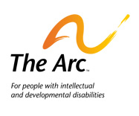

The Arc Position Statement Self-Determination PDF.
For more information on this and other topics, visit www.thearc.org.

Rights of Individuals with
Developmental Disabilities

Each person living in or receiving services in this facility has the following rights:
- You have the right to wear your own clothes. You should be able to pick the clothes you wear.
- You have the right to be treated well and with respect.
- You have the right to spend time alone or alone with a friend.
- You have the right to go to school.
- You have the right to see a doctor as soon as you need to.
- You have the right to be involved in a religion if you want to be.
- You have the right to meet people and take part in your community activities.
- You have the right to exercise and have fun.
- You have the right to say “NO” to drugs, being tied or held down, or being forced to be alone unless it is necessary to protect you or someone else.
- You have the right to say “NO” to things that will put you in danger.
- You have the right to make choices about where you live, who you live with, the way you spend your time and who you spend your time with.
- You may have other rights as provided by law or regulation.
- You have the right to keep and spend your own money on the things that
- You have the right to keep your own things in a private place that you can get into when you want.
- You have the right to see your friends, family, girlfriends or boyfriends every day.
- You have the right to use the telephone privately to make or get calls.
- You have the right to have paper, stamps and envelopes for writing letters.
- You have the right to mail and get letters that are not opened.
- You have the right to say “NO” to electric shock therapy.
- You have the right to say “NO” to anybody trying to change the way you act by hurting you, scaring you or upsetting you.
- You have the right to say “NO” to brain surgery that people want to do because of the way you act.
- You have the right to choose how you want to spend your free time and who you spend it with.
- You have the right to services that help you live, work and play in the most normal way possible.

The Department of Developmental Services would like to acknowledge the following: Capitol People First, Short Center North/DDSO Inc., Mayer- Johnson Co. No portion of this poster can be reproduced without prior permission from the Department of Developmental Services. For more information, call (916) 654-1888. Available online at www.dds.ca.gov.
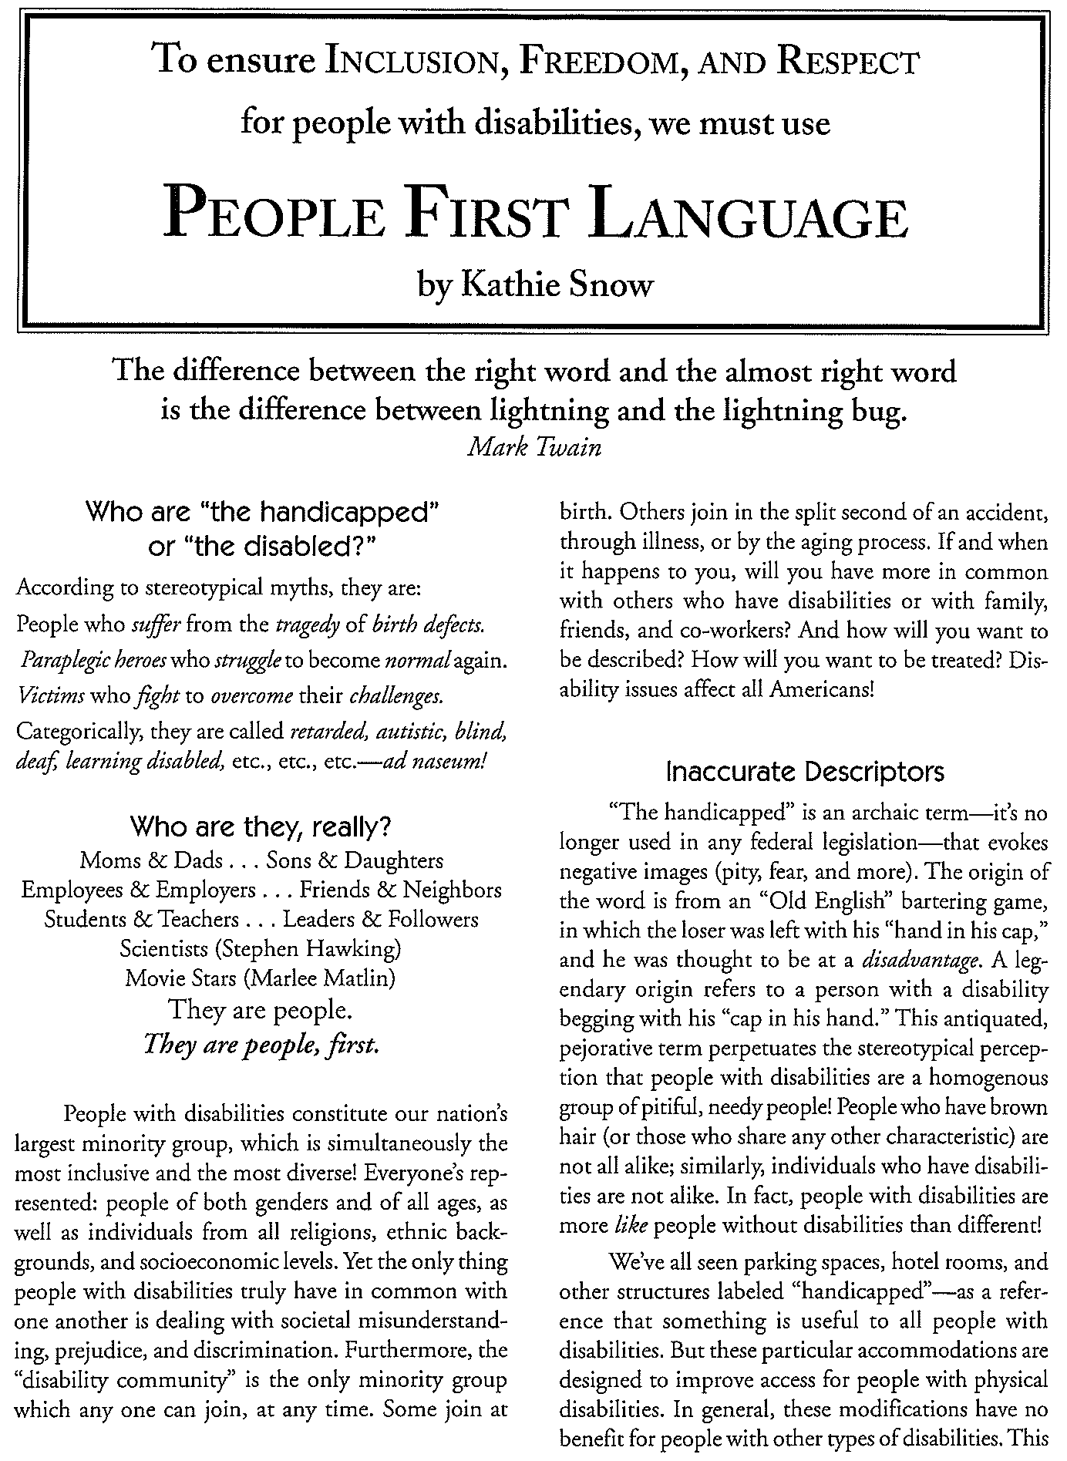

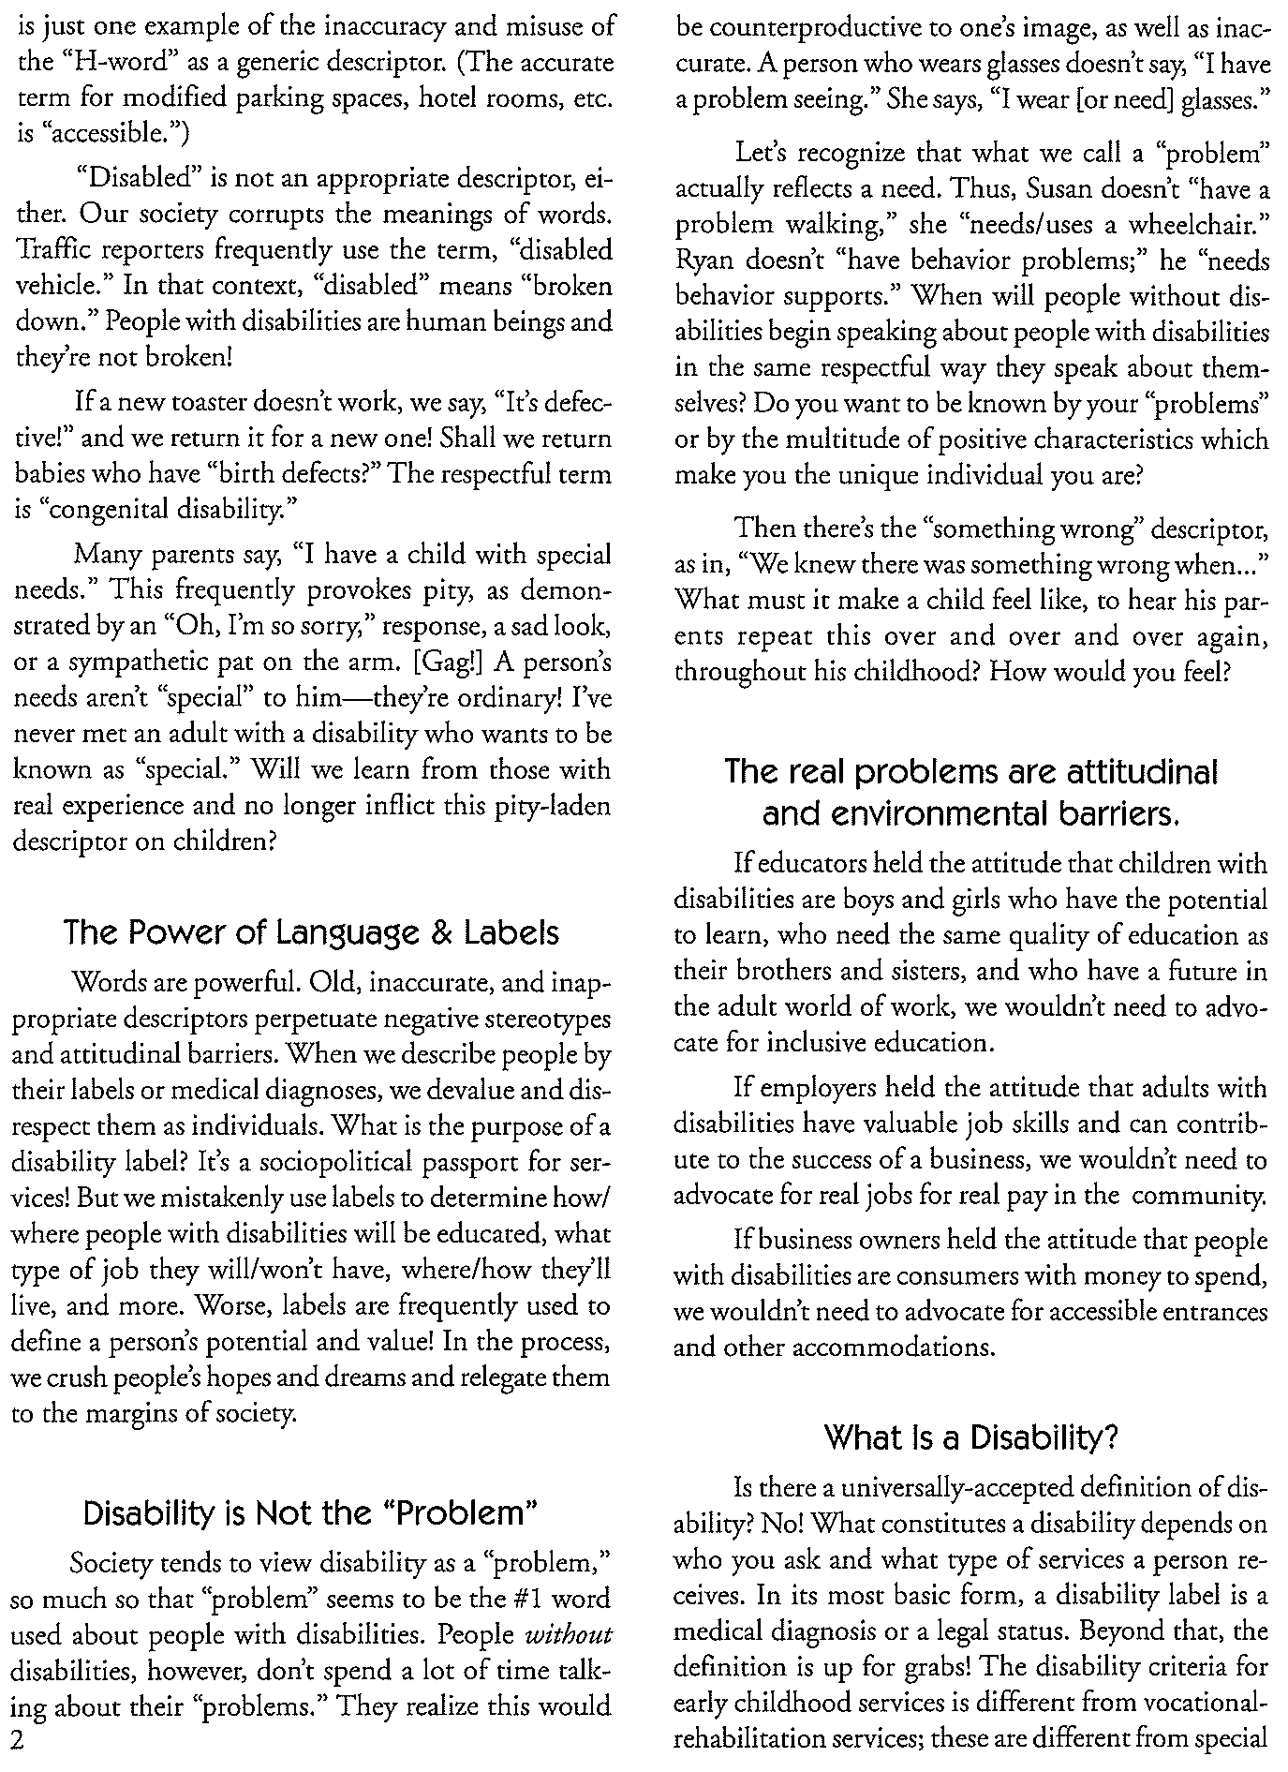

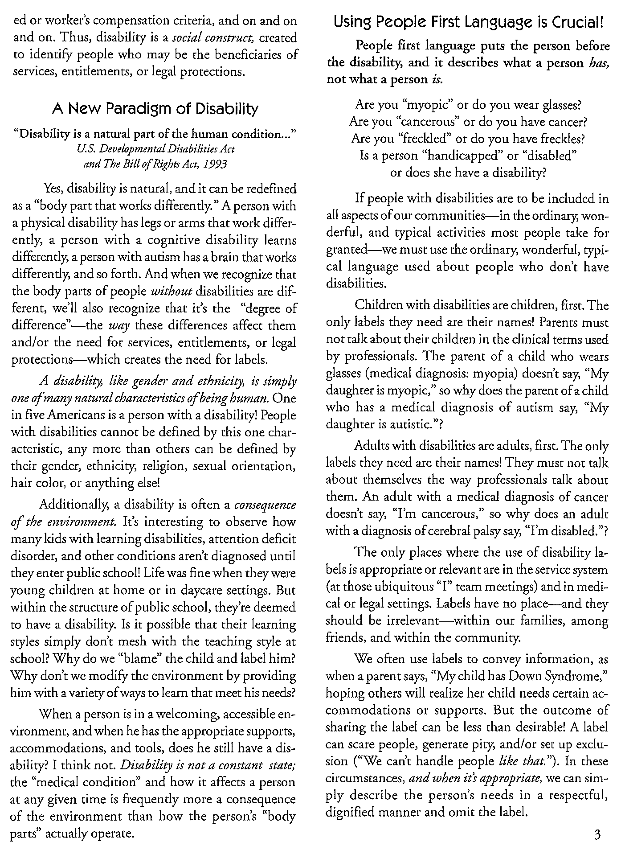

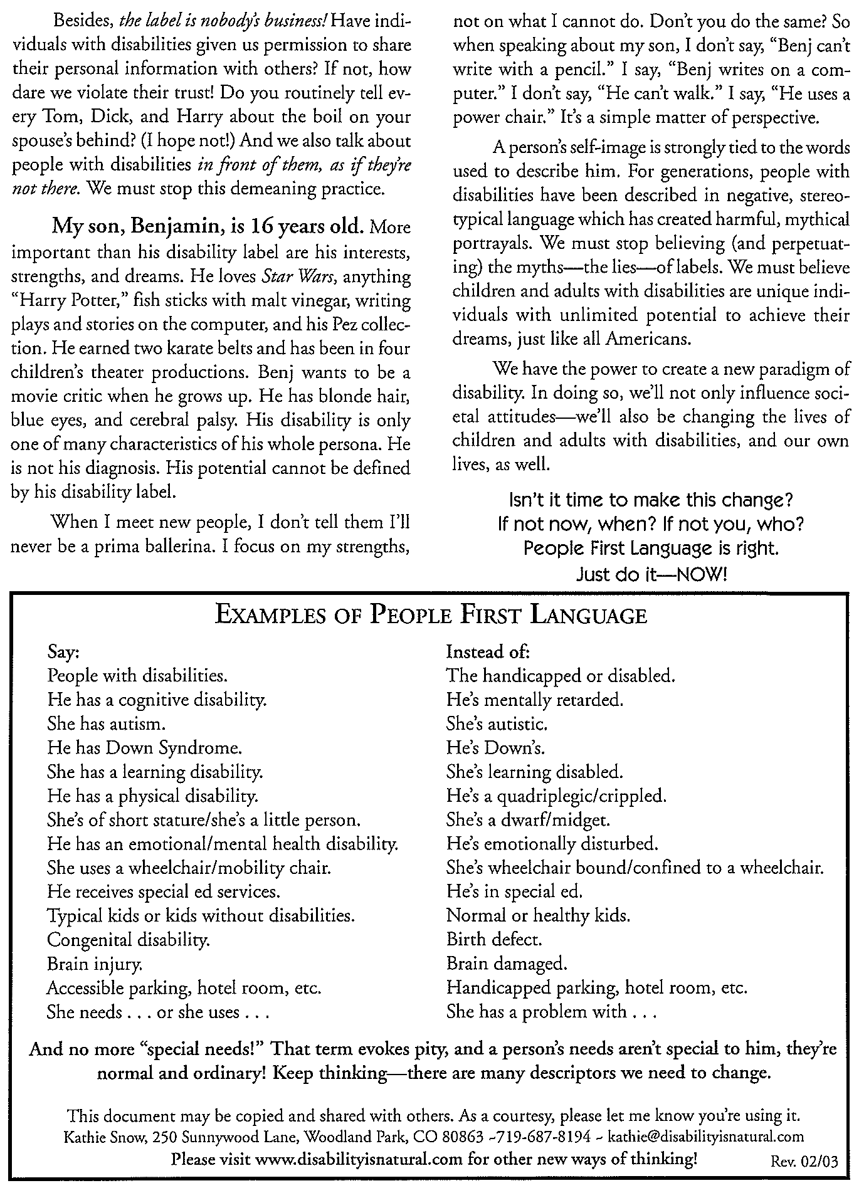

Identity First Language

Person-first language: A way of referring to a disabled person that emphasizes the person before the diagnosis, e.g. “person with autism.”

Identity-first language: A way of referring to a disabled person that emphasizes the disability as an identity, e.g. “autistic person.”

Although some disability communities choose to refer to themselves with person- first language (e.g. “person with an intellectual disability,”) many in the Autistic community join the majority of the Deaf and Blind communities in our embrace of identity-first language. This means that the Autistic community prefers to refer to ourselves as “autistic” rather than “having autism.”

Autistics choose this language with intention and full knowledge of the thought process behind it.

Many Autistics prefer identity-first language because we don’t see our autism as something separate from ourselves. Autism is a part of Autistic individuals, describing the way our brain works, rather than something that has been added to our being.

Person first language is often used to describe something negative—a deficit or disease (for example, person with cancer). Autistic people largely do not view our autism as an affliction and prefer that our language reflect that.

For Autistic people, autism is seen as just like any other identity marker— similar to gender, race, ethnicity, hair color, or any number of other value- neutral characteristics. We are not “people with tallness,” “people with maleness,” “people with Jewishness,” “people with gayness,” or “people with autism.” We are Autistic people.

Autistic people don’t want to be valued as people in spite of our autism; we want to be valued as Autistic people. When attempting to refer to Autistic people with respect, please remember that the most respectful thing you can do is refer to us in the manner in which we choose.

Article: Why I Dislike
“Person First Language”

Why I Dislike "Person First" Language
Jim Sinclair

I am not a "person with autism." I am an autistic person. Why does this distinction matter to me?

1 - Saying "person with autism" suggests that the autism can be separated from the person. But this is not the case. I can be separated from things that are not part of me, and I am still be the same person. I am usually a "person with a purple shirt," but I could also be a "person with a blue shirt" one day, and a "person with a yellow shirt" the next day, and I would still be the same person, because my clothing is not part of me. But autism is part of me. Autism is hard-wired into the ways my brain works. I am autistic because I cannot be separated from how my brain works.

2 - Saying "person with autism" suggests that even if autism is part of the person, it isn't a very important part. Characteristics that are recognized as central to a person's identity are appropriately stated as adjectives, and may even be used as nouns to describe people: We talk about "male" and "female" people, and even about "men" and "women" and "boys" and "girls," not about "people with maleness" and "people with femaleness." We describe people's cultural and religious identifications in terms such as "Russian" or "Catholic," not as "person with Russianity" or "person with Catholicism." We describe important aspects of people's social roles in terms such as "parent" or "worker," not as "person with offspring" or "person who has a job." We describe important aspects of people's personalities in terms such as "generous" or "outgoing," not as "person with generosity" or "person with extroversion." Yet autism goes deeper than culture and learned belief systems. It affects how we relate to others and how we find places in society. It even affects how we relate to our own bodies. If I did not have an autistic brain, the person that I am would not exist. I am autistic because autism is an essential feature of me as a person.

3 - Saying "person with autism" suggests that autism is something bad--so bad that is isn't even consistent with being a person. Nobody objects to using adjectives to refer to characteristics of a person that are considered positive or neutral. We talk about left-handed people, not "people with left-handedness," and about athletic or musical people, not about "people with athleticism" or "people with musicality." We might call someone a "blue-eyed person" or a "person with blue eyes," and nobody objects to either descriptor. It is only when someone has decided that the characteristic being referred to is negative that suddenly people want to separate it from the person. I know that autism is not a terrible thing, and that it does not make me any less a person. If other people have trouble remembering that autism doesn't make me any less a person, then that's their problem, not mine. Let them find a way to remind themselves that I'm a person, without trying to define an essential feature of my personhood as something bad. I am autistic because I accept and value myself the way I am.

Available online at http://www.cafemom.com/journals/read/436505.

From Lawrence Carter-Long: In its most literal sense, the prefix "dis" is not a synonym for "un" or "in" as is commonly and mistakenly assumed. It is much broader, bolder and more robust than that. So, you might ask, what does "dis" mean? In classical Latin, the primary meaning of the prefix "dis" translates to “two ways, in twain,” according to the Oxford English Dictionary. Twain literally means "in different directions, apart, asunder." Use of the prefix in this way has given us perfectly good words like “discern,” “discuss,” “dismiss,” “dissent” and “distill." When used in this way being disabled does not suggest a lack of anything
-- including ability, except perhaps to the uninformed or willfully ignorant. As such, correct use of the word disabled allows for a whole host of creative interpretations. For example, if being disillusioned means to be delivered from deception then it stands to reason that the presence of disability can have a similarly liberating effect. If we let it, disability can release us of the limited parameters of what "ability" is assumed to be. Disabled people are experts at adapting to a world that wasn't built with us in mind, at improvising to meet the moment, at finding innovative ways to get things done. The occurrence of disability, by design, opens up space for discovery, discernment and disruption. Similarly, the prefix “dis” needn't be something to be afraid of, angry about, or for that matter argued.

Session 1: Iron Triangle

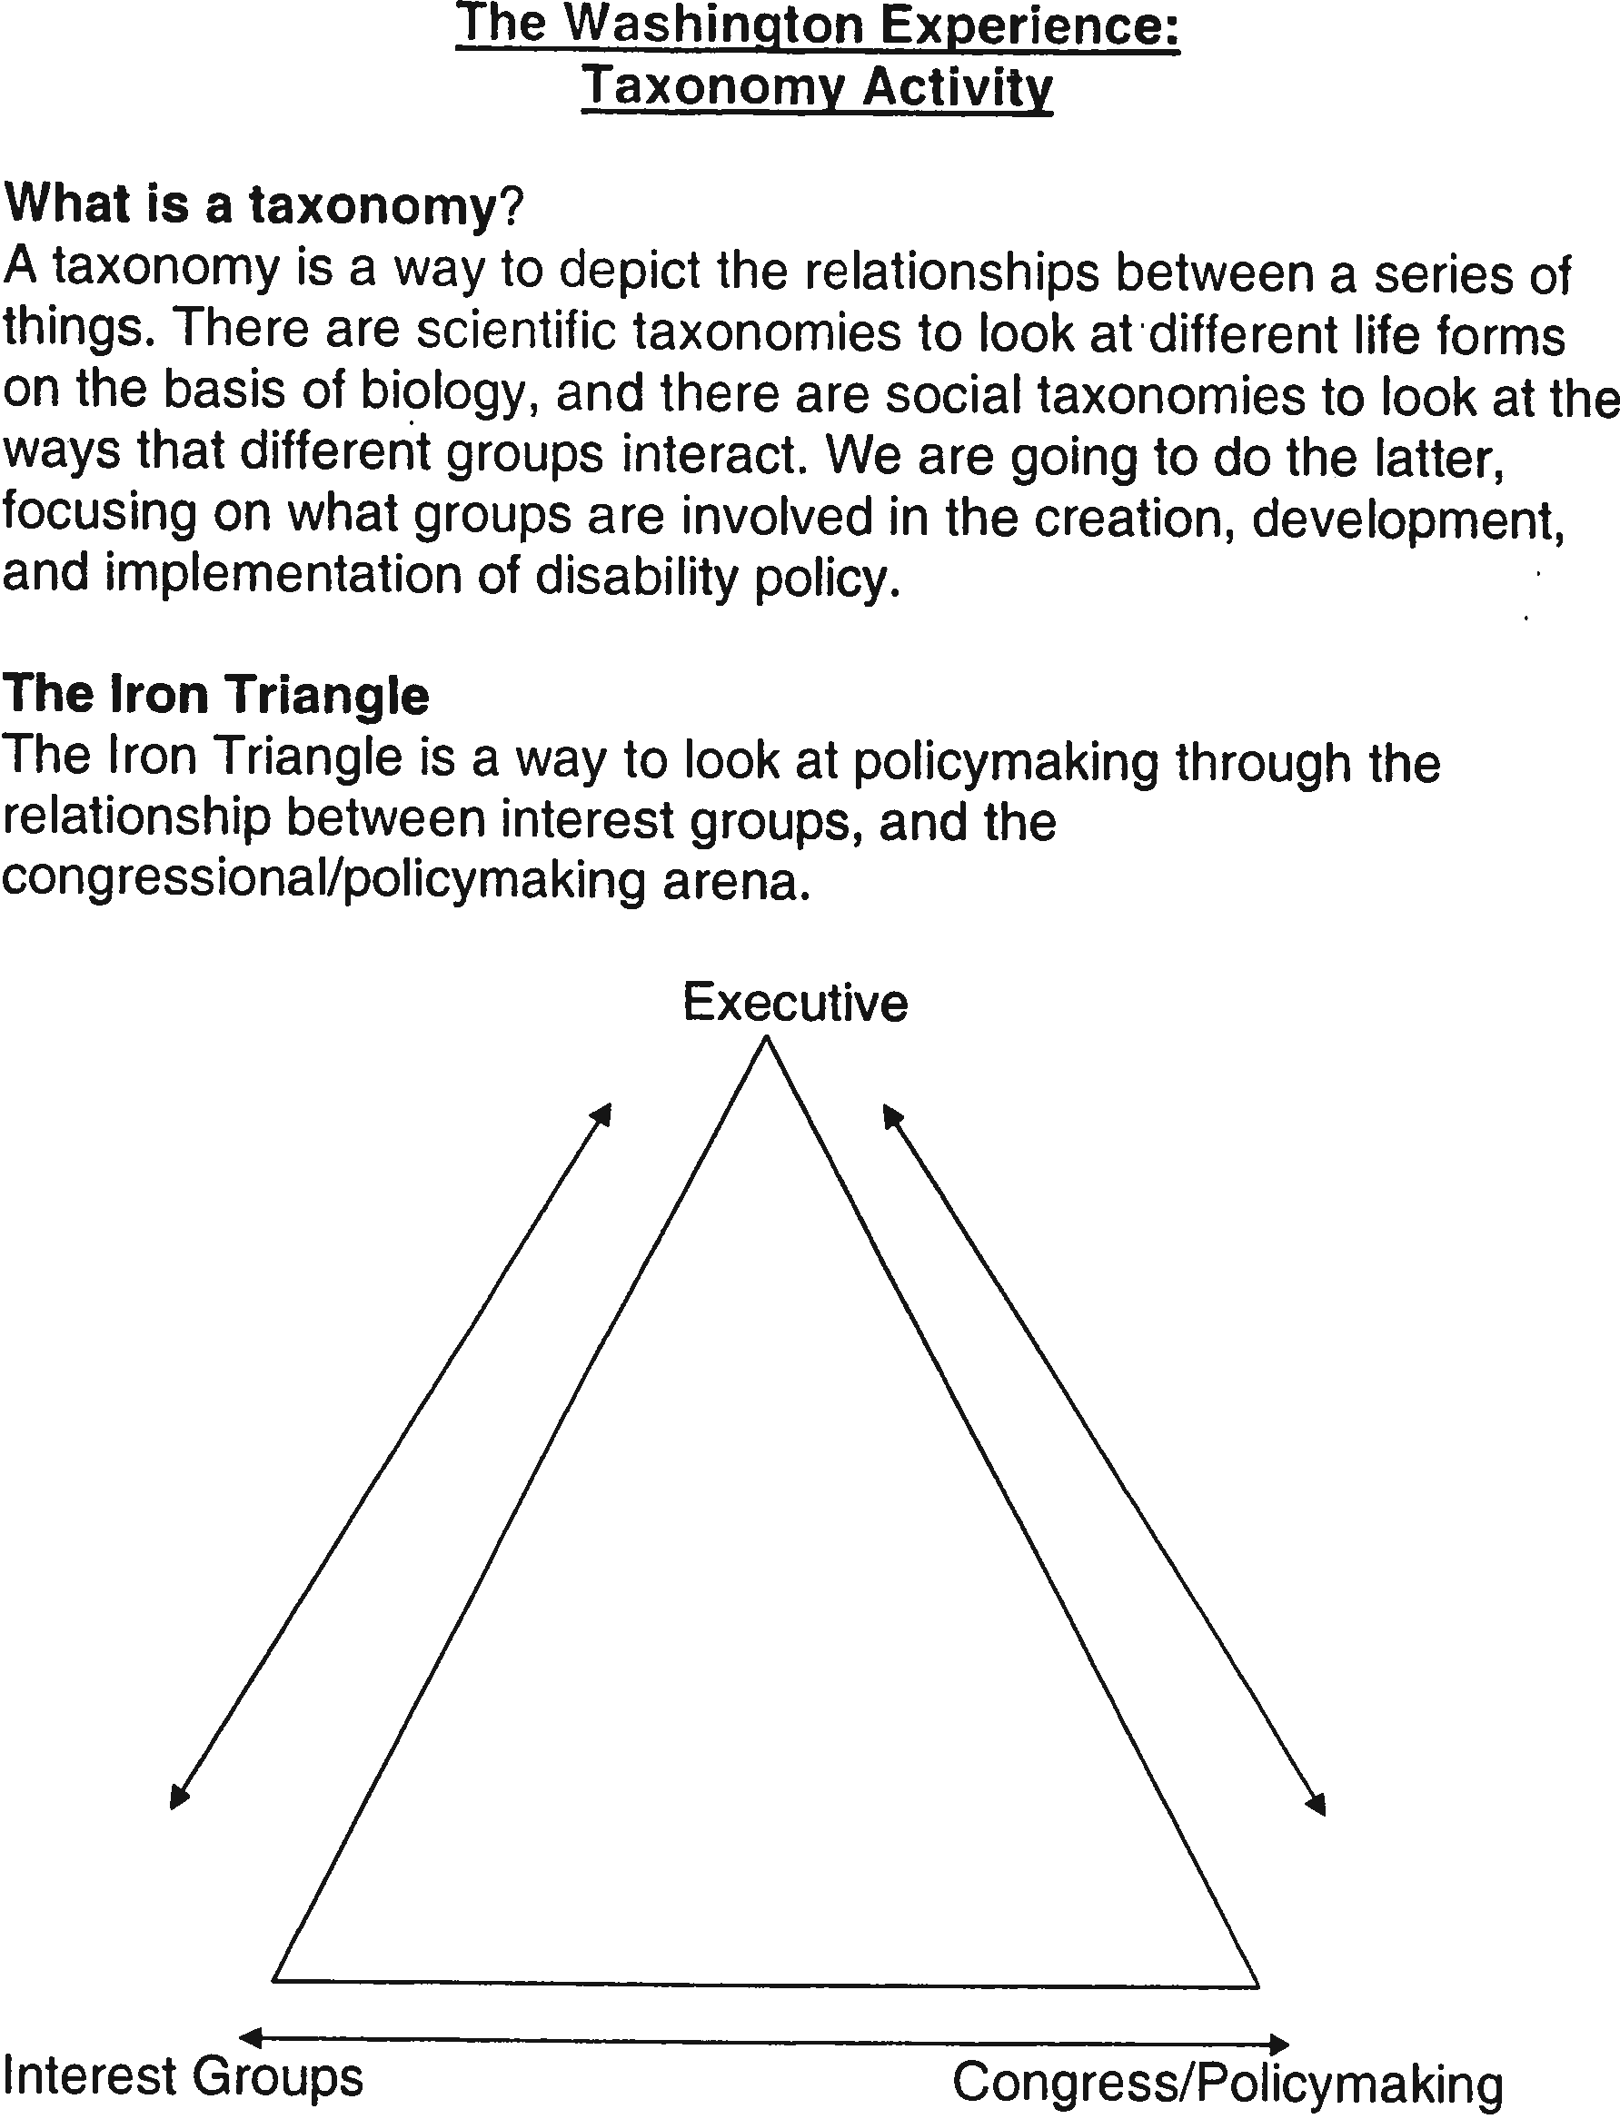

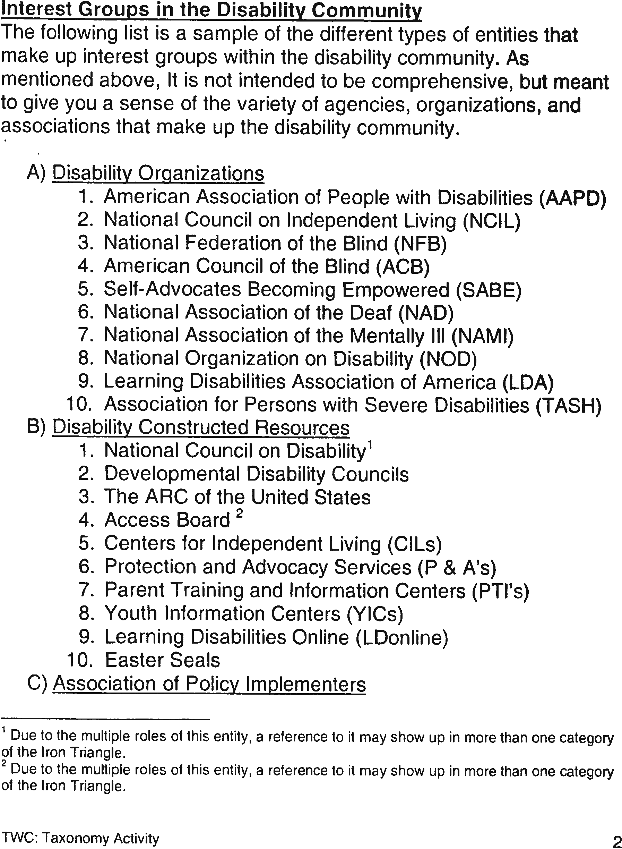
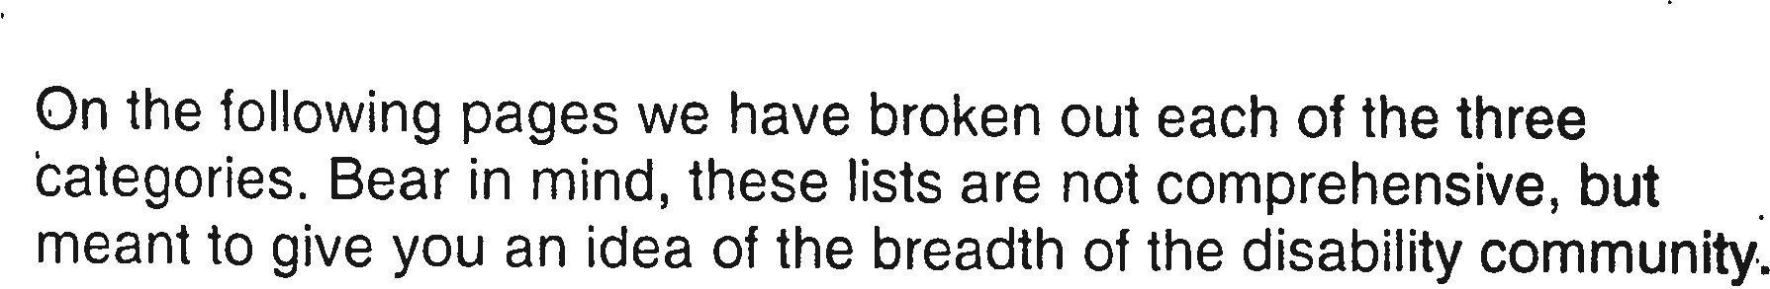

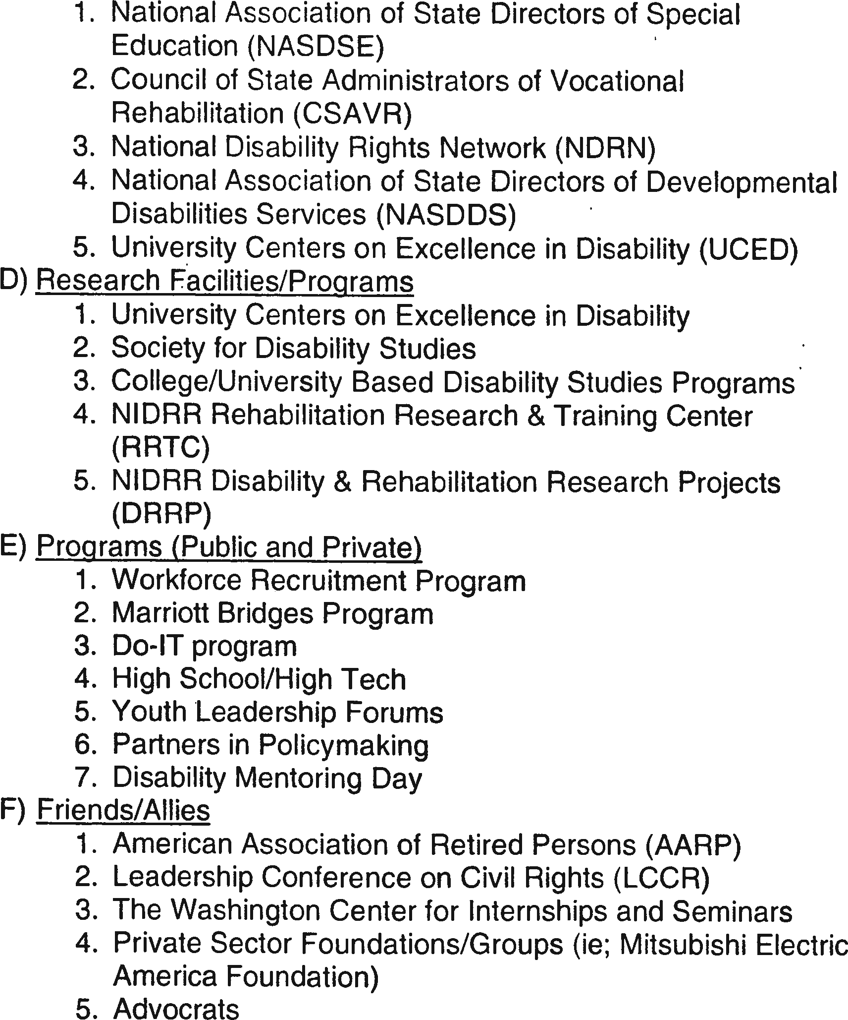

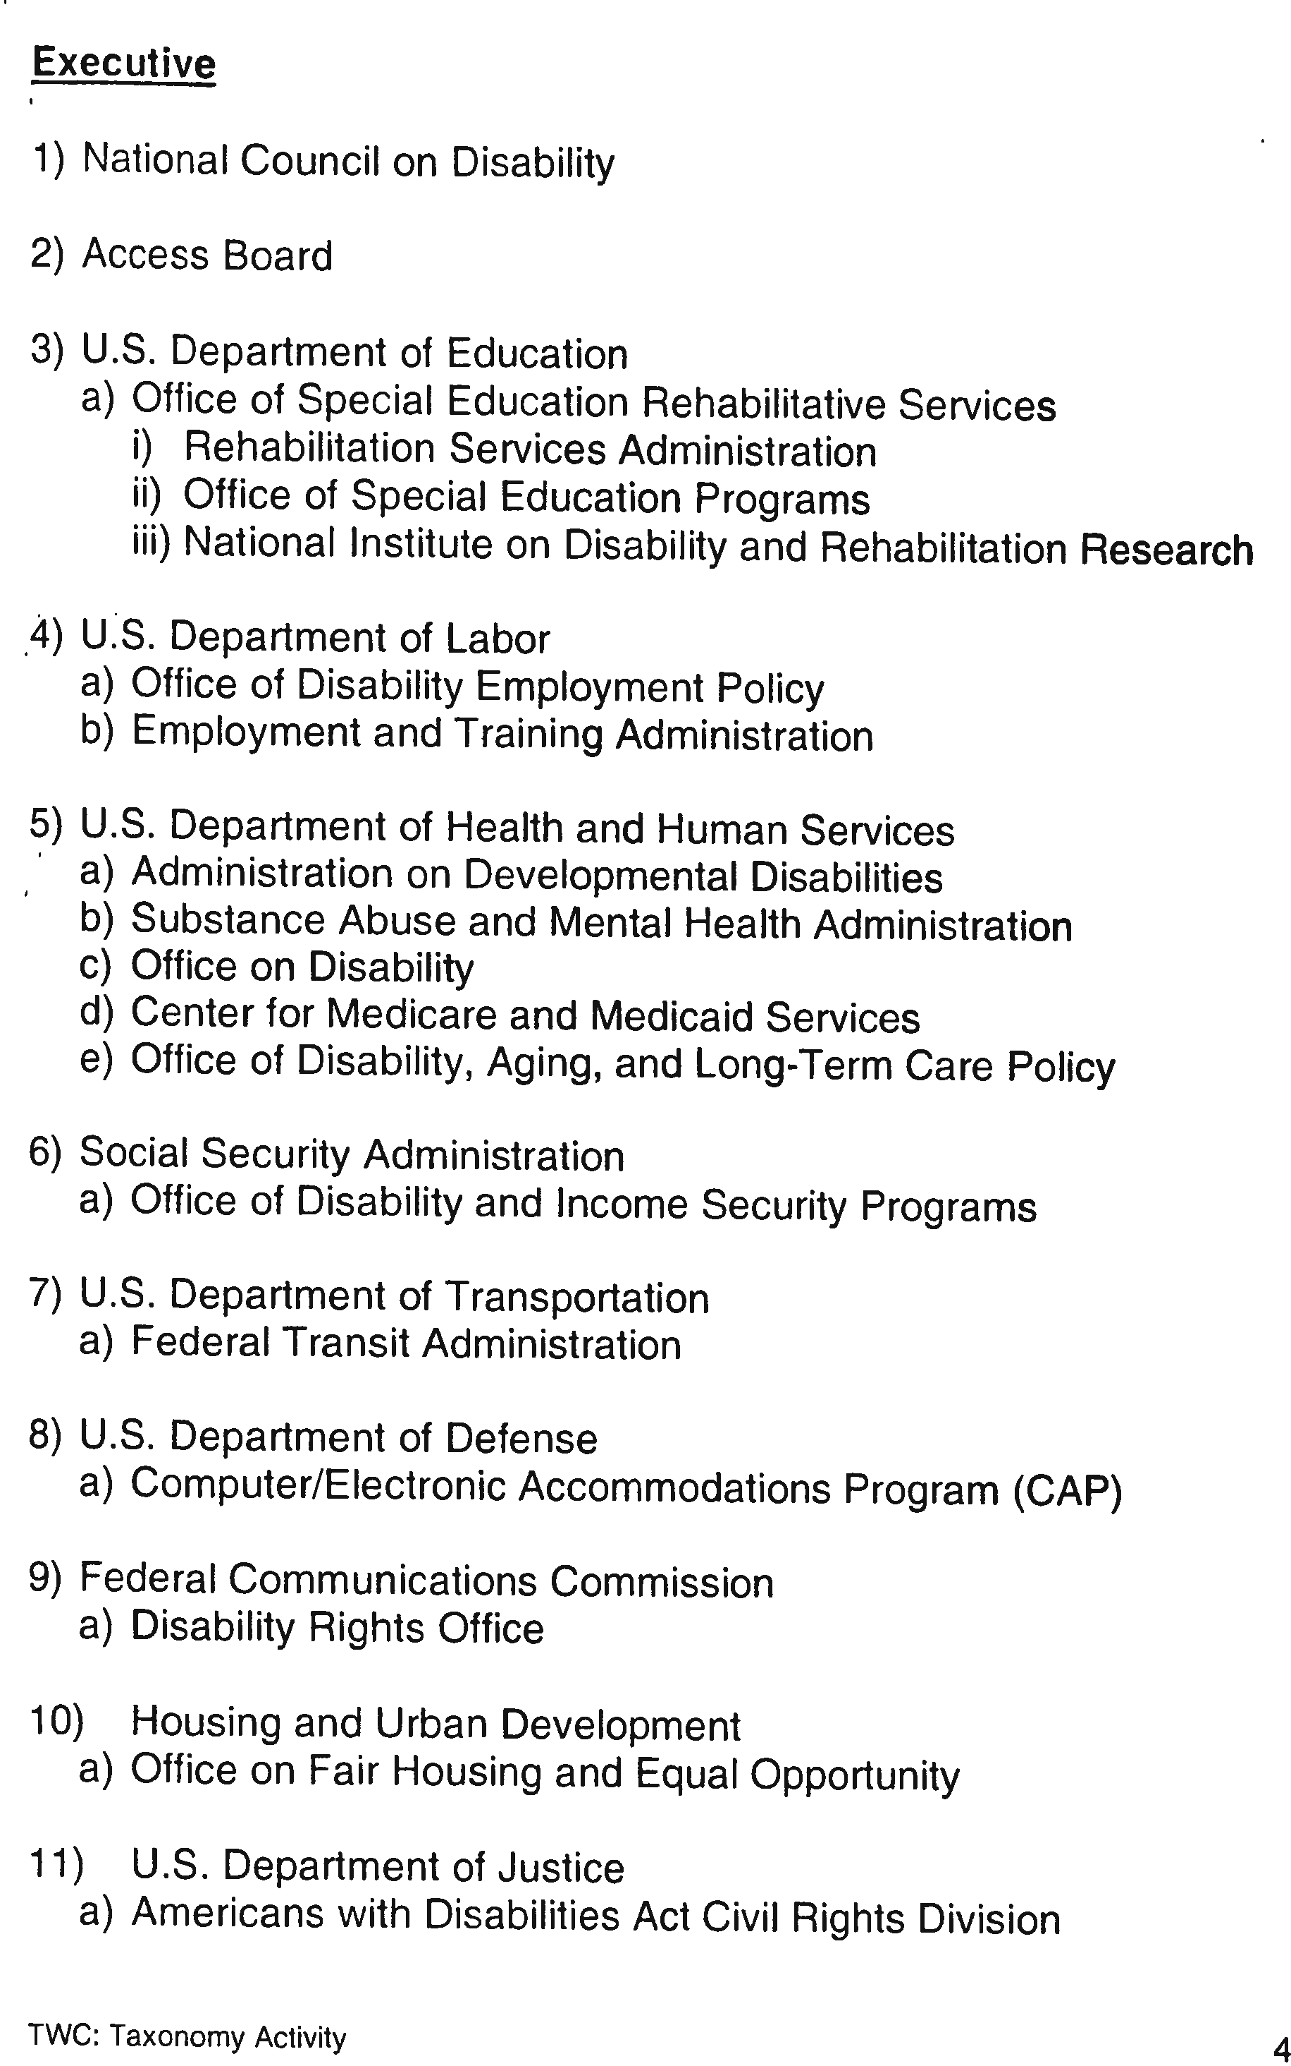

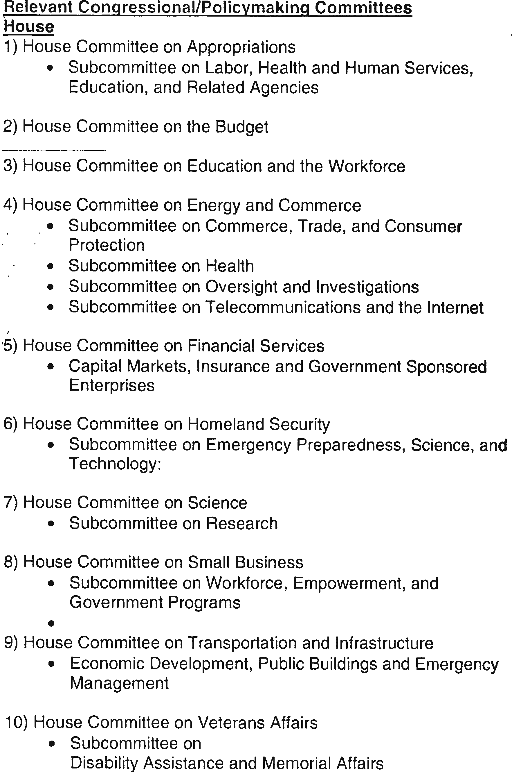

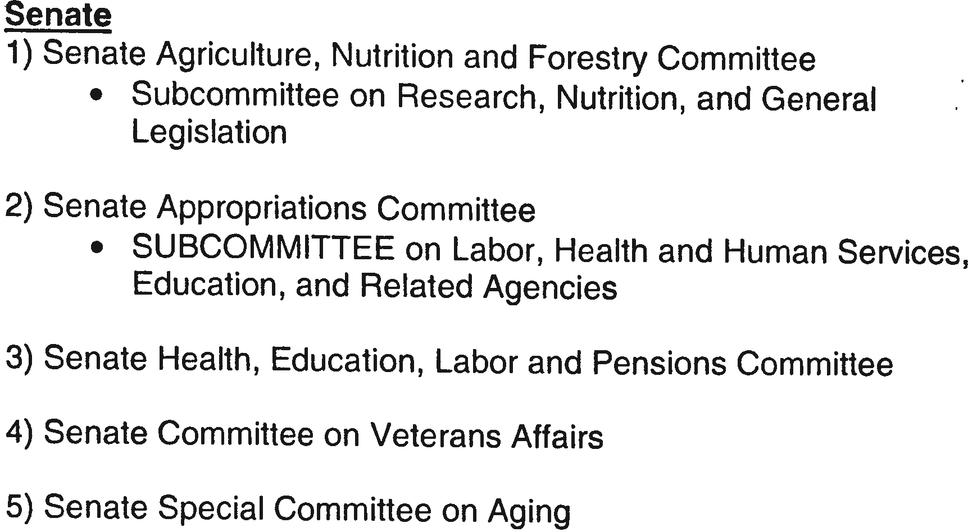
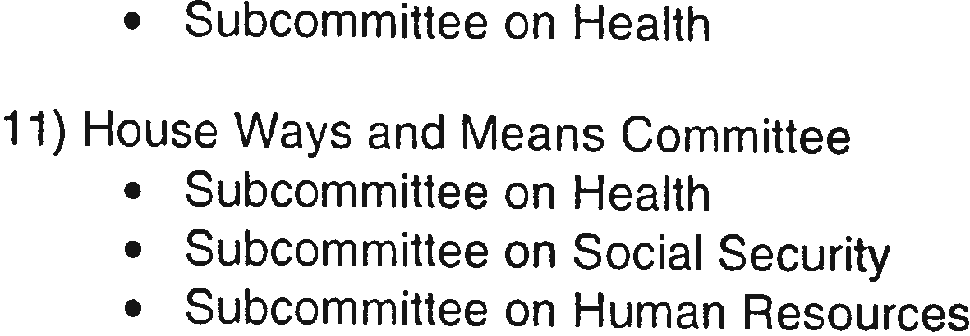

Session 1: Americans with Disabilities Act

Americans with Disabilities Act

Federal civil rights law designed to
  - Prevent discrimination
  - Enable participation

Goals
  - Equality of opportunity
  - Full participation
  - Independent living
  - Economic self-sufficiency

Social Model – fixing the environment rather than the person

Who has rights under this law? A three pronged definition
  - Physical or mental impairment that substantially limits one or more major life activity
  - Record of such an impairment
  - “Regarded as” having such an impairment

Titles (sections)
- Employment
- Public Transportation
- Public Accommodations
- Telecommunications

Places that do not comply?
  - No grandfathering
  - There is “undue burden” component

Session 1: Americans with Disabilities Act
Questions & Answers

Introduction

Barriers to employment, transportation, public accommodations, public services, and telecommunications have imposed staggering economic and social costs on American society and have undermined efforts by people with disabilities to receive an education, become employed, and be contributing members of society. By breaking down these barriers, the Americans with Disabilities Act (ADA) enables society to benefit from the skills, talents and purchasing power of individuals with disabilities and leads to fuller, more productive lives for all Americans.

The ADA gives civil rights protections to individuals with disabilities similar to those provided to individuals on the basis of race, color, sex, national origin, age, and religion. It guarantees equal opportunity for individuals with disabilities in public accommodations, employment, transportation, state and local government services, and telecommunications. This booklet is designed to provide answers to some of the most often asked questions about the ADA.

For answers to additional ADA questions, call the ADA National Network at 800-949-4232 (V/TTY). The ADA National Network is the “go to” resource for free information, guidance and training on the ADA and its implementation, tailored to meet the needs of business, government and individuals at local, regional and national levels. The ADA National Network consists of ten regional centers located throughout the United States. To identify the regional center that serves your state, visit the ADA National Network Website at http://adata.org/content/email-us. The ADA National Network offers numerous resources, many of which are either free or available at a low cost, including:
- ADA technical assistance via toll-free phone line and email
- Web-based training and information
- National ADA Symposium
- Regional and state training conferences
- ADA training webinars and podcasts
- ADA and disability related materials and products

The Americans with Disabilities Act Amendments Act (ADAAA) of 2008

The Americans with Disabilities Act Amendments Act (ADAAA) of 2008 was signed into law on September 25, 2008, and became effective on January 1, 2009. The ADAAA made a number of significant changes to the definition of “disability.” The law required the U.S. Equal Employment Opportunity Commission (EEOC) to amend its ADA regulations to reflect the changes made by the ADAAA. The final EEOC regulations were published in the Federal Register on March 25, 2011 and became effective on May 24, 2011.
The changes in the definition of disability in the ADAAA apply to all titles of the ADA, including title I (employment practices of private employers with 15 or more employees, state and local governments, employment agencies, labor unions, agents of the employer and joint management labor committees); title II (programs and activities of state and local government entities); and title III (private entities that are considered places of public accommodation).
The EEOC’s final regulations however apply to title I of the ADA only; they do not apply to titles II and III of the ADA. Other federal agencies, such as the U.S. Department of Justice, the U.S. Department of Transportation and the U.S. Department of Labor, will need to amend their regulations to reflect the changes in the definition of disability required by the ADAAA.

Employment
Q. Which employers are covered by title I of the ADA?
A. The title I employment provisions apply to private employers with 15 or more employees, state and local governments, employment agencies, labor unions, agents of the employer and joint management labor committees.

Q. What practices and activities are covered by the employment nondiscrimination requirements?
A. The ADA prohibits discrimination in all employment practices, including job application procedures, hiring, firing, advancement, compensation, training, and other terms, conditions, and privileges of employment. It applies to recruitment, advertising, tenure, layoff, leave, fringe benefits, and all other employment- related activities.

Q. Who is protected from employment discrimination?
A. Employment discrimination against individuals with disabilities is prohibited. This includes applicants for employment and employees. An individual is considered to have a "disability" if s/he has a physical or mental impairment that substantially limits a major life activity, has a record of such an impairment, or is regarded as having such an impairment. Persons discriminated against because they have a known association or relationship with an individual with a disability also are protected.

The first part of the definition makes clear that the ADA applies to persons who have impairments and that these must substantially limit major life activities. There are two non-exhaustive lists of examples of major life activities: caring for oneself, performing manual tasks, seeing, hearing, eating, sleeping, walking, standing, sitting, reaching, lifting, bending, speaking, breathing, learning, reading, concentrating, thinking, communicating, interacting with others, and working.

Major life activities also include the operation of major bodily functions, including: the immune system; special sense organs and skin; normal cell growth; and digestive, genitourinary, bowel, bladder, neurological, brain, respiratory, circulatory, cardiovascular, endocrine, hemic, lymphatic, musculoskeletal, and reproductive functions.

Examples of specific impairments that should easily be concluded to be disabilities include: deafness, blindness, intellectual disability, partially or completely missing limbs, mobility impairments, autism, cancer, cerebral palsy, diabetes, epilepsy, HIV infection, multiple sclerosis, muscular dystrophy, major depressive disorder, bipolar disorder, post-traumatic stress disorder, obsessive-compulsive disorder, and schizophrenia.

The second part of the definition protecting individuals with a record of a disability would cover, for example, a person who has recovered from cancer or mental illness.
Under the third part of the definition, a covered entity has regarded an individual as having a disability if it takes an action prohibited by the ADA (e.g., failure to hire, termination, or demotion) based on an individual’s impairment or on an impairment the covered entity believes the individual has, unless the impairment is transitory (lasting or expected to last for six months or less) and minor.

Q. Does the ADA require that an applicant or employee with a disability be qualified for the position?
A. Yes. The ADA defines qualified to mean a person who meets legitimate skill, experience, education, or other requirements of an employment position that s/he holds or seeks, and who can perform the essential functions of the position with or without reasonable accommodation. Requiring the ability to perform "essential" functions assures that an individual with a disability will not be considered unqualified simply because of inability to perform marginal or incidental job functions. If the individual is qualified to perform essential job functions except for limitations caused by a disability, the employer must consider whether the individual could perform these functions with a reasonable accommodation. If a written job description has been prepared in advance of advertising or interviewing applicants for a job, this will be considered as evidence, although not conclusive evidence, of the essential functions of the job.

Q. Does an employer have to give preference to an applicant with a disability over other applicants?
A. No. An employer is free to select the most qualified applicant available and to make decisions based on reasons unrelated to a disability. For example, suppose two persons apply for a job as a typist and an essential function of the job is to type 75 words per minute accurately. One applicant, an individual with a disability, who is provided with a reasonable accommodation for a typing test, types 50 words per minute; the other applicant who has no disability accurately types 75 words per minute. The employer can hire the applicant with the higher typing speed, if typing speed is needed for successful performance of the job.

Q. What limitations does the ADA impose on medical examinations and inquiries about disability?
A. An employer may not ask or require a job applicant to take a medical examination before making a job offer. It cannot make any pre-offer inquiry about a disability or the nature or severity of a disability. An employer may, however, ask questions about the ability to perform specific job functions and may, with certain limitations, ask an individual with a disability to describe or demonstrate how s/he would perform these functions.

An employer may condition a job offer on the satisfactory result of a post-offer medical examination or medical inquiry if this is required of all entering employees in the same job category. A post-offer examination or inquiry does not have to be job-related and consistent with business necessity.

However, if an individual is not hired because a post-offer medical examination or inquiry reveals a disability, the reason(s) for not hiring must be job-related and consistent with business necessity. The employer also must show that no reasonable accommodation was available that would enable the individual to perform the essential job functions, or that accommodation would impose an undue hardship. A post-offer medical examination may disqualify an individual if the employer can demonstrate that the individual would pose a "direct threat" in the workplace (i.e., a significant risk of substantial harm to the health or safety of the individual or others) that cannot be eliminated or reduced below the "direct threat" level through reasonable accommodation. Such a disqualification is job-related and consistent with business necessity. A post-offer medical examination may not disqualify an individual with a disability who is currently able to perform essential job functions because of speculation that the disability may cause a risk of future injury.

After a person starts work, a medical examination or inquiry of an employee must be job-related and consistent with business necessity. Employers may conduct employee medical examinations where there is evidence of a job performance or safety problem that they reasonably believe is caused by a medical condition, examinations required by other federal laws, return-to-work examinations when they reasonably believe that an employee will be unable to do his job or may pose a direct threat because of a medical condition, and voluntary examinations that are part of employee health programs.

Information from all medical examinations and inquiries must be kept apart from general personnel files as a separate, confidential medical record, available only under limited conditions.

Tests for illegal use of drugs are not medical examinations under the ADA and are not subject to the restrictions of such examinations.

Q. When can an employer ask an applicant to "self-identify" as having a disability?
A. A pre-employment inquiry about a disability is allowed if required by another federal law or regulation such as those applicable to veterans with disabilities and veterans of the Vietnam era. Pre-employment inquiries about disabilities may be necessary under such laws to identify applicants or clients with disabilities in order to provide them with required special services. An employer also may ask an applicant to self-identify as an individual with a disability when the employer is voluntarily using this information to benefit individuals with a disability.

Federal contractors and subcontractors who are covered by the affirmative action requirements of section 503 of the Rehabilitation Act of 1973 may invite individuals with disabilities to identify themselves on a job application form or by other pre- employment inquiry, to satisfy the section 503 affirmative action requirements. Employers who request such information must observe section 503 requirements regarding the manner in which such information is requested and used and the procedures for maintaining such information as a separate, confidential record, apart from regular personnel records.

Q. Does the ADA require employers to develop written job descriptions?
A. No. The ADA does not require employers to develop or maintain job descriptions. However, a written job description that is prepared before advertising or interviewing applicants for a job will be considered as evidence along with other relevant factors. If an employer uses job descriptions, they should be reviewed to make sure they accurately reflect the actual functions of a job. A job description will be most helpful if it focuses on the results or outcome of a job function, not solely on the way it customarily is performed. A reasonable accommodation may enable a person with a disability to accomplish a job function in a manner that is different from the way an employee who does not have a disability may accomplish the same function.

Q. What is "reasonable accommodation”?
A. Reasonable accommodation is any modification or adjustment to a job or the work environment that will enable an applicant or employee with a disability to participate in the application process or to perform essential job functions. Reasonable accommodation also includes adjustments to assure that an individual with a disability has rights and privileges in employment equal to those of employees without disabilities.

Q. What are some of the accommodations applicants and employees may need?
A. Examples of reasonable accommodation include making existing facilities used by employees readily accessible to and usable by an individual with a disability; restructuring a job; modifying work schedules; acquiring or modifying equipment; providing qualified readers or interpreters; or appropriately modifying examinations, training, or other programs. Reasonable accommodation also may include reassigning a current employee to a vacant position for which the individual is qualified, if the person is unable to do the original job because of a disability even with an accommodation. However, there is no obligation to find a position for an applicant who is not qualified for the position sought. Employers are not required to lower quality or production standards as an accommodation; nor are they obligated to provide personal use items such as wheelchairs, glasses or hearing aids.

The decision as to the appropriate accommodation must be based on the particular facts of each case. In selecting the particular type of reasonable accommodation to provide, the principal test is that of effectiveness, i.e., whether the accommodation will provide an opportunity for a person with a disability to achieve the same level of performance and to enjoy benefits equal to those of an average, similarly situated person without a disability. However, the accommodation does not have to ensure equal results or provide exactly the same benefits.
Q. When is an employer required to make a reasonable accommodation?
A. An employer is only required to accommodate a "known" disability of a qualified applicant or employee. The requirement generally will be triggered by a request from an individual with a disability, who frequently will be able to suggest an appropriate accommodation. Accommodations must be made on an individual basis, because the nature and extent of a disabling condition and the requirements of a job will vary in each case. If the individual does not request an accommodation, the employer is not obligated to provide one except where an individual's known disability impairs his/her ability to know of, or effectively communicate a need for, an accommodation that is obvious to the employer. If a person with a disability requests, but cannot suggest, an appropriate accommodation, the employer and the individual should work together to identify one. There are also many public and private resources that can provide assistance without cost.

Q. What are the limitations on the obligation to make a reasonable accommodation?
A. The individual with a disability requiring the accommodation must be otherwise qualified, and the disability must be known to the employer. In addition, an employer is not required to make an accommodation if it would impose an "undue hardship" on the operation of the employer's business. "Undue hardship" is defined as an "action requiring significant difficulty or expense" when considered in light of a number of factors. These factors include the nature and cost of the accommodation in relation to the size, resources, nature, and structure of the employer's operation. Undue hardship is determined on a case-by-case basis. Where the facility making the accommodation is part of a larger entity, the structure and overall resources of the larger organization would be considered, as well as the financial and administrative relationship of the facility to the larger organization. In general, a larger employer with greater resources would be expected to make accommodations requiring greater effort or expense than would be required of a smaller employer with fewer resources.

If a particular accommodation would be an undue hardship, the employer must try to identify another accommodation that will not pose such a hardship. Also, if the cost of an accommodation would impose an undue hardship on the employer, the individual with a disability should be given the option of paying that portion of the cost which would constitute an undue hardship or providing the accommodation.

Q. Must an employer modify existing facilities to make them accessible?
A. The employer's obligation under title I is to provide access for an individual applicant to participate in the job application process and for an individual employee with a disability to perform the essential functions of his/her job, including access to a building, work site, needed equipment, and all facilities used by employees. For example, if an employee lounge is located in a place inaccessible to an employee using a wheelchair, the lounge might be modified or relocated, or comparable facilities might be provided in a location that would enable the individual to take a break with co-workers. The employer must provide such access unless it would cause an undue hardship.

Under title I, an employer is not required to make its existing facilities accessible until a particular applicant or employee with a particular disability needs an accommodation, and then the modifications should meet that individual's specific medical needs. However, employers should consider initiating changes that will provide general accessibility, particularly for job applicants, since it is likely that people with disabilities will be applying for jobs. The employer does not have to make changes to provide access in places or facilities that will not be used by that individual for employment-related activities or benefits.

Q. Can an employer be required to reallocate an essential function of a job to another employee as a reasonable accommodation?
A. No. An employer is not required to reallocate essential functions of a job as a reasonable accommodation.

Q. Can an employer be required to modify, adjust, or make other reasonable accommodations in the way a test is given to an applicant or employee with a disability?
A. Yes. Accommodations may be needed to assure that tests or examinations measure the actual ability of an individual to perform job functions rather than reflect limitations caused by the disability. Tests should be given to people who have sensory, speaking, or manual impairments in a format that does not require the use of the impaired skill, unless it is a job-related skill that the test is designed to measure.

Q. Can an employer maintain existing production/performance standards for an employee with a disability?
A. An employer can hold employees with disabilities to the same standards of production/performance as other similarly situated employees without disabilities for performing essential job functions, with or without reasonable accommodation. An employer also can hold employees with disabilities to the same standards of production/performance as other employees regarding marginal functions unless the disability affects the person's ability to perform those marginal functions. If the ability to perform marginal functions is affected by the disability, the employer must provide some type of reasonable accommodation such as job restructuring but may not exclude an individual with a disability who is satisfactorily performing a job's essential functions.

Q. Can an employer establish specific attendance and leave policies?
A. An employer can establish attendance and leave policies that are uniformly applied to all employees, regardless of disability, but may not refuse leave needed by an employee with a disability if other employees get such leave. An employer also may be required to make adjustments in leave policy as a reasonable accommodation. The employer is not obligated to provide additional paid leave, but accommodations may include leave flexibility and unpaid leave.

A uniformly applied leave policy does not violate the ADA because it has a more severe effect on an individual because of his/her disability. However, if an individual with a disability requests a modification of such a policy as a reasonable accommodation, an employer may be required to provide it, unless it would impose an undue hardship.
Q. Can an employer consider health and safety when deciding whether to hire an applicant or retain an employee with a disability?
A. Yes. The ADA permits employers to establish qualification standards that will exclude individuals who pose a direct threat — i.e., a significant risk of substantial harm —to the health or safety of the individual or of others, if that risk cannot be eliminated or reduced below the level of a "direct threat" by reasonable accommodation. However, an employer may not simply assume that a threat exists; the employer must establish through objective, medically supportable methods that there is significant risk that substantial harm could occur in the workplace. By requiring employers to make individualized judgments based on reliable medical or other objective evidence rather than on generalizations, ignorance, fear, patronizing attitudes, or stereotypes, the ADA recognizes the need to balance the interests of people with disabilities against the legitimate interests of employers in maintaining a safe workplace.

Q. Are applicants or employees who are currently illegally using drugs covered by the ADA?
A. No. Individuals who currently engage in the illegal use of drugs are specifically excluded from the definition of an individual with a disability protected by the ADA when the employer takes action on the basis of their drug use.

Q. Is testing for the illegal use of drugs permissible under the ADA?
A. Yes. A test for the illegal use of drugs is not considered a medical examination under the ADA; therefore, employers may conduct such testing of applicants or employees and make employment decisions based on the results. The ADA does not encourage, prohibit, or authorize drug tests.
If the results of a drug test reveal the presence of a lawfully prescribed drug or other medical information, such information must be treated as a confidential medical record.

Q. Are alcoholics covered by the ADA?
A. Yes. While a current illegal user of drugs is not protected by the ADA if an employer acts on the basis of such use, a person who currently uses alcohol is not automatically denied protection. An alcoholic is a person with a disability and is protected by the ADA if s/he is qualified to perform the essential functions of the job. An employer may be required to provide an accommodation to an alcoholic. However, an employer can discipline, discharge or deny employment to an alcoholic whose use of alcohol adversely affects job performance or conduct. An employer also may prohibit the use of alcohol in the workplace and can require that employees not be under the influence of alcohol.

Q. Does the ADA override federal and state health and safety laws?
A. The ADA does not override health and safety requirements established under other federal laws even if a standard adversely affects the employment of an individual with a disability. If a standard is required by another federal law, an employer must comply with it and does not have to show that the standard is job related and consistent with business necessity. For example, employers must conform to health and safety requirements of the U.S. Occupational Safety and Health Administration. However, an employer still has the obligation under the ADA to consider whether there is a reasonable accommodation, consistent with the standards of other federal laws, which will prevent exclusion of individuals with disabilities who can perform jobs without violating the standards of those laws. If an employer can comply with both the ADA and another federal law, then the employer must do so.

The ADA does not override state or local laws designed to protect public health and safety, except where such laws conflict with the ADA requirements. If there is a state or local law that would exclude an individual with a disability from a particular job or profession because of a health or safety risk, the employer still must assess whether a particular individual would pose a "direct threat" to health or safety under the ADA standard. If such a "direct threat" exists, the employer must consider whether it could be eliminated or reduced below the level of a "direct threat" by reasonable accommodation. An employer cannot rely on a state or local law that conflicts with ADA requirements as a defense to a charge of discrimination.

Q. How does the ADA affect workers' compensation programs?
A. Only injured workers who meet the ADA's definition of an "individual with a disability" will be considered disabled under the ADA, regardless of whether they satisfy criteria for receiving benefits under workers' compensation or other disability laws. A worker also must be "qualified" (with or without reasonable accommodation) to be protected by the ADA. Although not all work-related injuries cause physical or mental impairments that “substantially limit” a major life activity, many on-the-job injuries may now constitute disabilities under the ADAAA’s broadened definition of “disability.”

An employer may not inquire into an applicant's workers' compensation history before making a conditional offer of employment. After making a conditional job offer, an employer may inquire about a person's workers’ compensation history in a medical inquiry or examination that is required of all applicants in the same job category. However, even after a conditional offer has been made, an employer cannot require a potential employee to have a medical examination because a response to a medical inquiry (as opposed to results from a medical examination) shows a previous on-the-job injury unless all applicants in the same job category are required to have an examination. Also, an employer may not base an employment decision on the speculation that an applicant may cause increased workers' compensation costs in the future. However, an employer may refuse to hire or may discharge an individual who is not currently able to perform a job without posing a significant risk of substantial harm to the health or safety of the individual or others if the risk cannot be eliminated or reduced by reasonable accommodation.

An employer may refuse to hire or may fire a person who knowingly provides a false answer to a lawful post-offer inquiry about his/her condition or workers’ compensation history.
An employer also may submit medical information and records concerning employees and applicants (obtained after a conditional job offer) to state workers' compensation offices and "second injury" funds without violating ADA confidentiality requirements.

Q. What is discrimination based on "relationship or association" under the ADA?
A. The ADA prohibits discrimination based on relationship or association in order to protect individuals from actions based on unfounded assumptions that their relationship to a person with a disability would affect their job performance, and from actions caused by bias or misinformation concerning certain disabilities. For example, this provision would protect a person whose spouse has a disability from being denied employment because of an employer's unfounded assumption that the applicant would use excessive leave to care for the spouse. It also would protect an individual who does volunteer work for people with AIDS from a discriminatory employment action motivated by that relationship or association.

Q. How are the employment provisions enforced?
A. The employment provisions of the ADA are enforced under the same procedures now applicable to race, color, sex, national origin, and religious discrimination under title VII of the Civil Rights Act of 1964, as amended, and the Civil Rights Act of 1991. Complaints may be filed with the Equal Employment Opportunity Commission or designated state human rights agencies. Available remedies will include hiring, reinstatement, promotion, back pay, front pay, restored benefits, reasonable accommodation, attorneys' fees, expert witness fees, and court costs. Compensatory and punitive damages also may be available in cases of intentional discrimination or where an employer fails to make a good faith effort to provide a reasonable accommodation. A charge must be filed within 180 calendar days from the date the discrimination took place. The 180 calendar day filing deadline is extended to 300 calendar days if a state or local agency enforces a law that prohibits employment discrimination on the same basis. A state’s designated human rights agency should be consulted to determine if the extended filing deadline applies.

Q. What financial assistance is available to employers to help them make reasonable accommodations and comply with the ADA?
A. A special tax credit is available to help smaller employers make accommodations required by the ADA. An eligible small business may take a tax credit of up to $5,000 per year for accommodations made to comply with the ADA. The credit is available for one-half the cost of "eligible access expenditures" that are more than $250 but less than $10,250.

A full tax deduction, up to $15,000 per year, also is available to any business for expenses of removing qualified architectural or transportation barriers. Expenses covered include costs of removing barriers created by steps, narrow doors, inaccessible parking spaces, restroom facilities, and transportation vehicles.

Q. What are an employer's recordkeeping requirements under the employment provisions of the ADA?
A. An employer must maintain records such as application forms submitted by applicants and other records related to hiring, requests for reasonable accommodation, promotion, demotion, transfer, lay-off or termination, rates of pay or other terms of compensation, and selection for training or apprenticeship for one year after making the record or taking the action described (whichever occurs later). If a charge of discrimination is filed or an action is brought by EEOC, an employer must save all personnel records related to the charge until final disposition of the charge.

Q. Does the ADA require that an employer post a notice explaining its requirements?
A. The ADA requires that employers post a notice describing the provisions of the ADA. It must be made accessible, as needed, to individuals with disabilities. A poster is available from EEOC summarizing the requirements of the ADA and other federal legal requirements for nondiscrimination for which EEOC has enforcement responsibility. EEOC also provides guidance on making this information available in accessible formats for people with disabilities.

State and Local Governments
Q. Does the ADA apply to state and local governments?
A. Title II of the ADA prohibits discrimination against qualified individuals with disabilities in all programs, activities, and services of public entities. It applies to all state and local governments, their departments and agencies, and any other instrumentalities or special purpose districts of state or local governments. It clarifies the requirements of section 504 of the Rehabilitation Act of 1973, as amended, for public transportation systems that receive federal financial assistance, and extends coverage to all public entities that provide public transportation, whether or not they receive federal financial assistance. It establishes detailed standards for the operation of public transit systems, including commuter and intercity rail (AMTRAK).

Q. How does title II affect participation in a state or local government's programs, activities, and services?
A. A state or local government must eliminate any eligibility criteria for participation in programs, activities, and services that screen out or tend to screen out persons with disabilities, unless it can establish that the requirements are necessary for the provision of the service, program, or activity. The state or local government may, however, adopt legitimate safety requirements necessary for safe operation if they are based on real risks, not on stereotypes or generalizations about individuals with disabilities. A public entity shall furnish appropriate auxiliary aids and services where necessary to afford qualified individuals with disabilities, including applicants, participants, companions, and members of the public, an equal opportunity to participate in, and enjoy the benefits of, a service, program, or activity of a public entity. Finally, a public entity must reasonably modify its policies, practices, or procedures to avoid discrimination. If the public entity can demonstrate that a particular modification would fundamentally alter the nature of its service, program, or activity, it is not required to make that modification.

Q. Does title II cover a public entity's employment policies and practices?
A. Yes. Title II prohibits all public entities, regardless of the size of their work force, from discriminating in employment against individuals with disabilities. In addition to title II's employment coverage, title I of the ADA and section 504 of the Rehabilitation Act of 1973 prohibit employment discrimination against individuals with disabilities by certain public entities.
Q. What changes must a public entity make to its existing facilities to make them accessible?
A. A public entity must ensure that individuals with disabilities are not excluded from services, programs, and activities because existing buildings are inaccessible. A state or local government's programs, when viewed in their entirety, must be readily accessible to and usable by individuals with disabilities. This standard, known as "program accessibility," applies to facilities of a public entity that existed on January 26, 1992. Public entities do not necessarily have to make each of their existing facilities accessible. They may provide program accessibility by a number of methods including alteration of existing facilities, acquisition or construction of additional facilities, relocation of a service or program to an accessible facility, or provision of services at alternate accessible sites.

Q. What is a self-evaluation?
A. A self-evaluation is a public entity's assessment of its current policies and practices. The self-evaluation identifies and corrects those policies and practices that are inconsistent with title II's requirements. All public entities should have completed a self- evaluation by January 26, 1993. A public entity that employs 50 or more employees must retain its self-evaluation for three years. Other public entities are not required to retain their self- evaluations, but are encouraged to do so because these documents evidence a public entity's good faith efforts to comply with title II's requirements.

Q. What does title II require for new construction and alterations?
A. The ADA requires that all new buildings constructed by a state or local government be accessible. In addition, when a state or local government undertakes alterations to a building, it must make the altered portions accessible.

Q. How will a state or local government know that a new building is accessible?
A. A state or local government will be in compliance with the ADA for new construction and alterations if it follows the 2010 ADA Standards for Accessible Design. Effective March 15, 2012, the 2010 ADA Standards must be used for new construction and alterations undertaken by state and local governments.

Q. What requirements apply to a public entity's emergency telephone services, such as 911?
A. State and local agencies that provide emergency telephone services must provide "direct access" to individuals who rely on a teletypewriter (TTY, also known as a telecommunication device for deaf persons or TDD) or computer modem for telephone communication. Telephone access through a third party or through a relay service does not satisfy the requirement for direct access. Where a public entity provides 911 telephone service, it may not substitute a separate seven-digit telephone line as the sole means for access to 911 services by non-voice users. A public entity may, however, provide a separate seven-digit line for the exclusive use of non-voice callers in addition to providing direct access for such calls to its 911 line.

Q. How are the ADA's requirements for state and local governments enforced?
A. Private individuals may bring lawsuits to enforce their rights under title II and may receive the same remedies as those provided under section 504 of the Rehabilitation Act of 1973, including reasonable attorney's fees. Individuals may also file complaints with eight designated federal agencies, including the Department of Justice and the Department of Transportation.

The ADA National Network can assist individuals with disabilities by providing ADA information related to access to services, programs, and activities provided by public entities. The ADA National Network is also a valuable resource for ADA coordinators in government entities in cities, towns, villages and counties, and in state agencies and departments. Contact the ADA National Network with your questions or to find a regional ADA National Network center near you. Call (800) 949-4232 (V/TTY); all calls are confidential.

Public Accommodations
Q. What are public accommodations?
A. A public accommodation is a private entity that owns, operates, leases, or leases to, a place of public accommodation. Places of public accommodation include a wide range of entities, such as restaurants, hotels, theaters, doctors' offices, pharmacies, retail stores, museums, libraries, parks, private schools, and day care centers. Private membership clubs and religious organizations are exempt from the ADA's title III requirements for public accommodations.

Q. Does the ADA have any effect on the eligibility criteria used by public accommodations to determine who may receive services?
A. Yes. If a criterion screens out or tends to screen out individuals with disabilities, it may only be used if necessary for the provision of the services. For instance, it would be a violation for a retail store to have a rule excluding all deaf persons from entering the premises, or for a movie theater to exclude all individuals with cerebral palsy. More subtle forms of discrimination are also prohibited. For example, requiring presentation of a driver's license as the sole acceptable means of identification for purposes of paying by check could constitute discrimination against individuals who are blind or have low vision. This would be true if such individuals are ineligible to receive licenses and the use of an alternative means of identification is feasible.

Q. Does the ADA allow public accommodations to take safety factors into consideration in providing services to individuals with disabilities?
A. The ADA expressly provides that a public accommodation may exclude an individual if that individual poses a direct threat to the health or safety of others that cannot be mitigated by appropriate modifications in the public accommodation's policies or procedures or by the provision of auxiliary aids. A public accommodation will be permitted to establish objective safety criteria for the operation of its business; however, any safety standard must be based on objective requirements rather than stereotypes or generalizations about the ability of persons with disabilities to participate in an activity.

Q. Are there any limits on the kinds of modifications in policies, practices, and procedures required by the ADA?

A. Yes. The ADA does not require modifications that would fundamentally alter the nature of the services provided by the public accommodation. For example, it would not be discriminatory for a physician specialist who treats only burn patients to refer a deaf individual to another physician for treatment of a broken limb or respiratory ailment. To require a physician to accept patients outside of his or her specialty would fundamentally alter the nature of the medical practice.

Q. What kinds of auxiliary aids and services are required by the ADA to ensure effective communication with individuals who are deaf/hard of hearing or who are blind/have low vision?
A. Appropriate auxiliary aids and services for individuals who are deaf or hard of hearing may include services and devices such as qualified interpreters on-site or through video remote interpreting (VRI) services; note takers; real-time computer-aided transcription services; written materials; exchange of written notes; telephone handset amplifiers; assistive listening devices; assistive listening systems; telephones compatible with hearing aids; closed caption decoders; open and closed captioning, including real-time captioning; voice, text, and video-based telecommunications products and systems, including text telephones (TTYs), videophones, and captioned telephones, or equally effective telecommunications devices; videotext displays; accessible electronic and information technology; or other effective methods of making aurally delivered information available to individuals who are deaf or hard of hearing.

Appropriate auxiliary aids and services for individuals who are blind or have low vision may include services and devices such as qualified readers; taped texts; audio recordings; Brailed materials and displays; screen reader software; magnification software; optical readers; secondary auditory programs (SAP); large print materials; accessible electronic and information technology; or other effective methods of making visually delivered materials available to individuals who are blind or have low vision.

Q. Are there any limitations on the ADA's auxiliary aids requirements?
A. Yes. The ADA does not require the provision of any auxiliary aid that would result in an undue burden or in a fundamental alteration in the nature of the goods or services provided by a public accommodation. However, the public accommodation is not relieved from the duty to furnish an alternative auxiliary aid, if available, that would not result in a fundamental alteration or undue burden. Both of these limitations are derived from existing regulations and are to be determined on a case-by-case basis.

Q. Do businesses need to have Braille materials, such as menus and sales tags, on hand in order to comply with title III?
A. Generally no, as long as a restaurant has waiters or waitresses that are qualified to read menus or retail stores have sales staff that are qualified to read sales tags to blind customers.
Q. Do businesses need to have a qualified interpreter on hand in order to communicate with a person who is deaf?
A. Generally no, not if employees are able to communicate by using pen and notepad and it is effective. However, in situations where the exchange of information is over a long duration or the information being exchanged is complex, it may be necessary for the business to provide a qualified interpreter. A business should discuss this with the person with the disability to determine which auxiliary aid or service will result in effective communication.

Q. What is the definition of a service animal under the ADA?
A. A service animal is any dog that is individually trained to do work or perform tasks for the benefit of an individual with a disability, including a physical, sensory, psychiatric, intellectual, or other mental disability. Other species of animals, whether wild or domestic, trained or untrained, are not considered to be service animals. Examples of work or tasks include, but are not limited to, assisting individuals who are blind or have low vision with navigation and other tasks, alerting individuals who are deaf or hard of hearing to the presence of people or sounds, providing non-violent protection or rescue work, pulling a wheelchair, assisting an individual during a seizure, alerting individuals to the presence of allergens, retrieving items such as medicine or the telephone, providing physical support and assistance with balance and stability to individuals with mobility disabilities, and helping individuals with psychiatric and neurological disabilities by preventing or interrupting impulsive or destructive behaviors. The crime deterrent effects of an animal’s presence and the provision of emotional support, well-being, comfort, or companionship do not constitute work or tasks.

Q. What type of inquiries can be made about the use of a service animal?
A. To determine if an animal is a service animal, a public entity or a private business may ask two questions: 1) Is this animal required because of a disability? and 2) What work or task has this animal been trained to perform? These inquires may not be made if the need for the service animal is obvious (e.g., the dog is guiding an individual who is blind or is pulling a person’s wheelchair.) A public entity or private business may not ask about the nature or extent of an individual’s disability. They also may not require documentation, such as proof that the animal has been certified, trained or licensed as a service animal, or require the animal to wear an identifying vest.

Q. Are miniature horses service animals?
A. No, however a public entity or private business shall make reasonable modifications in policies, practices, or procedures to permit the use of a miniature horse by an individual with a disability if the miniature horse has been individually trained to do work or perform tasks for the benefit of the individual with a disability. Factors that a covered entity may consider in determining when such a modification is reasonable include the type, size, and weight of the miniature horse and whether the facility can accommodate these features; whether the individual has sufficient control of the animal; whether the animal is housebroken; and whether legitimate safety requirements that are necessary for operation of the business or program will be compromised.

Beyond these additional considerations, a covered entity may only make the same kinds of inquiries permitted in the case of service dogs and may not ask about the nature of the individual's disability or require documentation that the miniature horse is trained.

Q. What is the definition of a wheelchair under the ADA?
A. A wheelchair is a manually operated or power-driven device designed primarily for use by an individual with a mobility disability for the main purpose of indoor, or of both indoor and outdoor, locomotion. Individuals with mobility disabilities must be permitted to use wheelchairs and manually powered mobility aids, i.e., walkers, crutches, canes, braces, or other similar devices designed for use by individuals with mobility disabilities, in any areas open to pedestrian traffic.

Q. What is an other power-driven mobility device (OPDMD)?
A. An OPDMD is any mobility device powered by batteries, fuel, or other engines that is used by individuals with mobility disabilities for the purpose of locomotion, whether or not it was designed primarily for use by individuals with mobility disabilities. OPDMDs may include golf cars, electronic personal assistance mobility devices, such as the Segway® Personal Transporter (PT), or any mobility device that is not a wheelchair, which is designed to operate in areas without defined pedestrian routes. Covered entities must make reasonable modifications in their policies, practices, or procedures to permit individuals with mobility disabilities to use OPDMDs unless the entity can demonstrate that the class of OPDMDs cannot be operated in accordance with legitimate safety requirements adopted by the entity.

Q. Are there any limitations on the ADA's barrier removal requirements for existing facilities?
A. Yes. Barriers must be removal when it is "readily achievable" to do so.

Q. What does the term "readily achievable" mean?
A. It means "easily accomplishable and able to be carried out without much difficulty or expense."

Q. What are examples of the types of modifications that would be readily achievable in most cases?
A. Examples include the simple ramping of a few steps, the installation of grab bars where only routine reinforcement of the wall is required, the lowering of telephones, and similar modest adjustments.

Q. Will businesses need to rearrange furniture and display racks?
A. Possibly. For example, restaurants may need to rearrange tables and department stores may need to adjust their layout of racks and shelves in order to permit access to wheelchair users.

Q. Will businesses need to install elevators?
A. Businesses are not required to retrofit their existing facilities to install elevators unless such installation is readily achievable, which is unlikely in most cases.

Q. When barrier removal is not readily achievable, what kinds of alternative steps are required by the ADA?
A. Alternatives may include such measures as in-store assistance for removing articles from inaccessible shelves, home delivery of groceries, or coming to the door to receive or return dry cleaning.

Q. Must alternative steps be taken without regard to cost?
A. No, only readily achievable alternative steps must be undertaken.

Q. How is "readily achievable" determined in a multisite business?
A. In determining whether an action to make a public accommodation accessible would be "readily achievable," the overall size of the parent corporation or entity is only one factor to be considered. The ADA also permits consideration of the financial resources of the particular facility or facilities involved and the administrative or fiscal relationship of the facility or facilities to the parent entity.

Q. Are businesses entitled to any tax benefit to help pay for the cost of compliance?
A. Yes, Businesses may be eligible for available tax credits and deductions. As amended in 1990, the Internal Revenue Code allows a deduction of up to $15,000 per year for expenses associated with the removal of qualified architectural and transportation barriers.

The 1990 amendment also permits eligible small businesses to receive a tax credit for certain costs of compliance with the ADA. An eligible small business is one whose gross receipts do not exceed $1,000,000 or whose workforce does not consist of more than 30 full-time workers. Qualifying businesses may claim a credit of up to 50 percent of eligible access expenditures that exceed $250 but do not exceed $10,250. Examples of eligible access expenditures include the necessary and reasonable costs of removing architectural, physical, communications, and transportation barriers; providing readers, interpreters, and other auxiliary aids; and acquiring or modifying equipment or devices.

Q. Who has responsibility for ADA compliance in leased places of public accommodation, the landlord or the tenant?
A. The ADA places the legal obligation to remove barriers or provide auxiliary aids and services on both the landlord and the tenant. The landlord and the tenant may decide by lease who will actually make the changes and provide the aids and services, but both remain legally responsible.

Q. What does the ADA require in new construction?
A. The ADA requires that all newly constructed facilities housing places of public accommodation, as well as commercial facilities such as office buildings, be accessible.

Q. What standards must places of public accommodation and commercial facilities follow?
A. Places of public accommodation must follow the 2010 ADA Standards for Accessible Design for barrier removal, new construction and alterations. Commercial facilities must follow the 2010 ADA Standards for Accessible Design for new construction and alterations. The 2010 ADA Standards for Accessible Design set minimum requirements – both scoping and technical -- for newly designed and constructed or altered public accommodations and commercial facilities to be readily accessible to and usable by individuals with disabilities. Elevators are generally not required in facilities under three stories or with fewer than 3,000 square feet per floor, unless the building is a shopping center or mall; the professional office of a health care provider; a terminal, depot, or other public transit station; or an airport passenger terminal.

Q. Is it expensive to make all newly constructed places of public accommodation and commercial facilities accessible?
A. The cost of incorporating accessibility features in new construction is less than one percent of construction costs. This is a small price in relation to the economic benefits to be derived from full accessibility in the future, such as increased employment and consumer spending.

Q. Must every feature of a new facility be accessible?
A. No, only a specified number of elements such as entrances, parking spaces and drinking fountains must be made accessible in order for a facility to be "readily accessible."

Q. What are the ADA requirements for altering facilities?
A. All alterations that could affect the usability of a facility must be made in an accessible manner to the maximum extent feasible. For example, if during renovations a doorway is being relocated, the new doorway must be wide enough to meet the new construction standard for accessibility. When alterations are made to a primary function area, such as the lobby of a bank or the dining area of a cafeteria, an accessible path of travel to the altered area must also be provided.

The bathrooms, telephones, and drinking fountains serving that area must also be made accessible. These additional accessibility alterations are only required to the extent that the added accessibility costs do not exceed 20% of the cost of the original alteration. Elevators are generally not required in facilities under three stories or with fewer than 3,000 square feet per floor, unless the building is a shopping center or mall; the professional office of a health care provider; a terminal, depot, or other public transit station; or an airport passenger terminal.

Q. Does the ADA permit an individual with a disability to sue a business when that individual believes that discrimination is about to occur, or must the individual wait for the discrimination to occur?
A. The ADA public accommodation provisions permit an individual to allege discrimination based on a reasonable belief that discrimination is about to occur. This provision, for example, allows a person who uses a wheelchair to challenge the planned construction of a new place of public accommodation, such as a shopping mall, that would not be accessible to individuals who use wheelchairs. The resolution of such challenges prior to the construction of an inaccessible facility would enable any necessary remedial measures to be incorporated in the building at the planning stage, when such changes would be relatively inexpensive.
Q. How does the ADA affect existing state and local building codes?
A. Existing codes remain in effect. The ADA allows the Attorney General to certify that a state law, local building code, or similar ordinance that establishes accessibility requirements meets or exceeds the minimum accessibility requirements for public accommodations and commercial facilities. Any state or local government may apply for certification of its code or ordinance. The Attorney General can certify a code or ordinance only after prior notice and a public hearing at which interested people, including individuals with disabilities, are provided an opportunity to testify against the certification.

Q. What is the effect of certification of a state or local code or ordinance?
A. Certification can be advantageous if an entity has constructed or altered a facility according to a certified code or ordinance. If someone later brings an enforcement proceeding against the entity, the certification is considered "rebuttable evidence" that the state law or local ordinance meets or exceeds the minimum requirements of the ADA. In other words, the entity can argue that the construction or alteration met the requirements of the ADA because it was done in compliance with the state or local code that had been certified.

Q. How will the public accommodations provisions be enforced?
A. Private individuals may bring lawsuits in which they can obtain court orders to stop discrimination. Individuals may also file complaints with the U.S. Department of Justice, which is authorized to bring lawsuits in cases of general public importance or where a "pattern or practice" of discrimination is alleged. In these cases, the Justice Department may seek monetary damages and civil penalties. Civil penalties may not exceed $55,000 for a first violation or $110,000 for any subsequent violation.

The ADA National Network can assist individuals with disabilities by providing ADA information related to access to the goods and services provided by places of public accommodation. The ADA National Network can also provide businesses with information on meeting the needs of people with disabilities. Contact the ADA National Network with your questions or to find a regional ADA National Network center near you. Call (800) 949-4232 (V/TTY); all calls are confidential.
Return to Table of Contents

Miscellaneous
Q. Is the federal government covered by the ADA?
A. The ADA does not cover the executive branch of the federal government. The executive branch continues to be covered by title V of the Rehabilitation Act of 1973, which prohibits discrimination in services and employment on the basis of disability and which is a model for the requirements of the ADA. The ADA, however, does cover Congress and other entities in the legislative branch of the federal government.

Q. Does the ADA cover private apartments and private homes?
A. The ADA does not cover strictly residential private apartments and homes. If, however, a place of public accommodation is located in a residential setting, such as a rental/sales office, doctor's office or day care center, those portions of the residential property used for that purpose are subject to the ADA's requirements.

Q. Does the ADA cover air transportation?
A. Discrimination by air carriers in areas other than employment is not covered by the ADA, but rather by the Air Carrier Access Act (49 U.S.C. 1374 (c)).

Q. What are the ADA's requirements for public transit buses?
A. The Department of Transportation has issued regulations mandating accessible public transit vehicles and facilities. The regulations include requirements that all new fixed-route, public transit buses be accessible and that supplementary paratransit services be provided for those individuals with disabilities who cannot use fixed-route bus service. For information on how to contact the Department of Transportation, see page 25-26.

Q. How will the ADA make telecommunications accessible?
A. The ADA requires the establishment of telephone relay services for individuals who use teletypewriters (TTYs, also known as telecommunications devices for deaf persons or TDDs), video phones, or similar devices. The Federal Communications Commission has issued regulations specifying standards for the operation of these services.

https://adata.org/publication/ADA-faq-booklet.
The information in this booklet has been adapted from “The Americans with Disabilities Act Questions and Answers” document produced by the U.S. Equal Employment Opportunity Commission and U.S. Department of Justice, Civil Rights Division, October 2008 version.
This publication was produced as a collaborative project by the ADA National Network, which is funded by the U.S. Department of Education, National Institute on Disability and Rehabilitation Research. This document does not reflect the opinions of the U.S. Department of Education and is not a legal determination of your rights and/or responsibilities under the ADA. It is provided as technical assistance and you should consult an attorney for legal matters.
Copyright © 2013. All rights reserved.
Call us toll-free 1-800-949-4232 V/TTY Find your regional center at www.adata.org.

Outside Events for
Community Involvement

Advocates for Justice and Education
Calendar of Training & Events

DATE | TIME | TOPIC | LOCATION

DCAP Team & Speakers
Biographies

Carly Fahey

Email: faheyc@iel.org
Telephone: 202-822-8405 Ext. 122

Carly Fahey joined IEL in 2016. She supports the National Collaborative on Workforce and Disability for Youth, DC Advocacy Partners, and the Vocational Rehabilitation Youth Technical Assistance Center. Prior to joining IEL, Carly served as the Outreach Coordinator of Diversity, Philanthropy, and Community Relations at the global headquarters of Computer Sciences Corporation (CSC), where she supported internal employee resource groups and created communications and diversity outreach for the CSC Charitable Foundation.

Prior to this, Carly worked as a programming support consultant for Family CAFÉ Inc. and CAFÉ TA in Florida. Carly was also an intern with the Executive Office of the Florida Governor in the Office of Policy and Budget and the Florida Gubernatorial Fellowship. She is a former vice chair and policy committee leader of the Youth Advisory Committee (YAC) to the National Council on Disability (NCD), a committee that provided youth reports and perspectives to NCD, the organization that advises Congress and the White House on disability policy.

Through her work with YAC, Carly was the youngest person in history to receive unanimous Senate Confirmation. Carly’s history with IEL began in 2005, when she served as a founding member of a project called the Florida Youth Council (FYC). With the support of IEL, the FYC created disability history and awareness legislation for Florida public schools that was signed into law in 2008. Carly attended the University of Utah, graduating with a B.S. in Communications. There, she participated in a research and service learning project focused on preventative healthcare policy and HIV/AIDS in Vancouver, Canada.

DCAP Team & Speakers
Biographies

Jessica Fuentes-Diaz

Email: fuentesdiazj@iel.org
Telephone: 202-822-8405 Ext. 144

Jessica joined IEL in December 2017. As Program Associate, she supports the Vocational Rehabilitation Youth Technical Assistance Center, a groundbreaking initiative that provides state vocational rehabilitation programs and related professionals with technical assistance and training to help more effectively serve youth with disabilities.

Prior to joining IEL, Jessica interned as a Law Clerk for the U.S Department of Justice. Under the Environment and Natural Resources Division, she did extensive research on prior legislation as well as writing about findings and supported attorneys in organizing paperwork and information in preparation for trials, hearings, and depositions. Jessica was also a Refugee and Migration Intern at Save the Children, an international non-governmental organization that promotes children’s rights, provides relief and helps support children in developing countries. There, Jessica reviewed and edited proposals and reports prior to submission to donors, including the US State Department and the UN Refugee Agency.

She volunteers her time as a Child Advocate with The Young Center for Immigrant Children’s Rights, a human rights organization that serves as trusted allies for children while they are in deportation proceedings, advocating for their best interests, and standing for the creation of a dedicated children’s immigrant justice system that ensures the safety and well-being of every child.

Jessica graduated from George Mason University with a major in International Affairs concentrating in Global Economy and Management and a minor in Cultural Anthropology. While at Mason, she studied Arabic language in Rabat, Morocco and took classes on foreign investment and global development at the University of Havana in Cuba. Jessica speaks English, Spanish, and is learning Arabic.

DCAP Team & Speakers
Biographies

Judith E. Heumann
U.S. Department of State
Special Advisor
International Disability Rights

Judith Heumann is an internationally recognized leader in the disability community and a lifelong civil rights advocate for disadvantaged people. Most recently, Judy was a Ford Foundation Senior Fellow from 2017-2019. She was appointed by President Obama to be the Special Advisor for International Disability Rights at the U.S. Department of State and finished her appointment in 2016. She previously served as the Director for the Department on Disability Services for the District of Columbia, where she was responsible for the Developmental Disability Administration and the Rehabilitation Services Administration.
From June 2002- 2006, Judith E. Heumann served as the World Bank's first Adviser on Disability and Development. In this position, Heumann led the World Bank's disability work to expand the Bank’s knowledge and capability to work with governments and civil society on including disability in the Bank discussions with client countries; its country-based analytical work; and support for improving policies, programs, and projects that allow disabled people around the world to live and work in the economic and social mainstream of their communities. She was Lead Consultant to the Global Partnership for Disability and Development.
From 1993 to 2001, Heumann served in the Clinton Administration as the Assistant Secretary for the Office of Special Education and Rehabilitative Services in the Department of Education. Heumann was responsible for the implementation of legislation at the national level for programs in special education, disability research, vocational rehabilitation and independent living, serving more than 8 million youth and adults with disabilities.
For more than 30 years, Heumann has been involved on the international front working with disabled people’s organizations and governments around the world to advance the human rights of disabled people. She represented Education Secretary, Richard Riley, at the 1995 International Congress on Disability in Mexico City. She was a US delegate to the Fourth United Nations World Conference on Women in Beijing, China. She has been active with Disabled Peoples’ International, Rehabilitation International and numerous Independent Living Centers throughout the world. She co-founded the Center for Independent Living in Berkeley California and the World Institute on Disability in Oakland California.
Heumann graduated from Long Island University in 1969 and received her Master’s in Public Health from the University of California at Berkeley in 1975. She has received numerous awards including being the first recipient of the Henry B. Betts Award in recognition of efforts to significantly improve the quality of life for people with disabilities. She has received an Honorary Doctorate of Humane Letters from Long Island University in Brooklyn, an Honorary Doctor of Public Administration from the University of Illinois, Champaign, and an Honorary Doctorate of Public Service from the University of Toledo.

You can contact Judy at judithheumann1@gmail.com.

DCAP Team & Speakers
Biographies

Taryn M. Williams
Taryn Williams most recently served at the Office of Disability Employment Policy (ODEP) at the U.S. Department of Labor where she was a Supervisory Policy Advisor on the Youth Policy Team and a Senior Policy Advisor. At ODEP, Williams provided expertise in several disability policy areas including workforce development, education, youth development, Medicaid and Social Security. As a member of the Youth Team, she led an initiative to build federal and state capacity to provide and measure the outcomes of transition services and a demonstration project targeting youth with disabilities in community colleges. She also worked to enhance transition outcomes of youth with significant disabilities. Taryn Former Associate Director in the Office of Public Engagement
From 2014 to 2016, Taryn Williams was an Associate Director in the Office of Public Engagement and served as the White House’s liaison to the disability community.
Prior to joining at ODEP and the White House, Taryn was Research Coordinator for Leadership Programs at the Institute for Educational Leadership (IEL). At IEL, she managed a leadership development program for teachers, administrators, and policymakers, including a focus on special education. In addition, she conducted policy analysis and research in several areas including federal education legislation and preparation of the education workforce. Before joining IEL, Taryn was Director of Programs at the National Association of Urban Debate Leagues (NAUDL) headquartered in Chicago. At NAUDL, she developed and delivered policy debate curricula for secondary school teachers in urban school districts.
Taryn earned a bachelor’s degree in Public Policy with a concentration in education from Brown University. She holds a master’s degree in Education with a concentration in Administration, Planning, and Social Policy from Harvard University. She participated in the Education Policy Fellowship Program at IEL in 2006-2007. In 2012-2013, she completed a detail to the United States Senate Health, Education, Labor, and Pensions Committee (HELP), which is chaired by Senator Tom Harkin. At HELP, she researched and contributed to the staff report on the ADA Generation.

You can contact Taryn at tarynmackenziewilliams@gmail.com.

