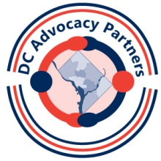
Session 6 Homework Assignment

- Testify at transportation hearing to be held Saturday, June 30, 2012 at 1:00 PM at 1800 Good Hope Rd, SE, Washington, DC 20020. They want to hear your thoughts and ideas on how to make transportation accessible, safe, affordable, flexible and efficient in the District of Columbia. For more information or to request reasonable accommodations, please contact Christina Mitchell at 202-481-3877.
Hand in at the July meeting: a copy of your written testimony
- Build a relationship with your city council member and promote disability issues. Make an appointment to visit your city council representative and tell him/her about DC AP and your final project, and why this issue is important to people with disabilities. And be sure to give him/her your Partners business card.

Hand in at the July meeting: a paper with the name of your councilmember, date of your visit, and a few sentences about how the meeting went and any follow-up plans.

- Contact Councilman Jim Graham about DDRA and why it should be acted upon. We want them to know that we are very interested in this important legislation.

Hand in at the July meeting: a copy of your letter

- Write a letter to the editor of any local newspaper about a disability issue that is important to you. It could be based on the topic of your long term project.
Hand in at the July meeting: a copy of your letter and a copy of it in the newspaper if the paper used it.
- Visit the website for TASH at www.tash.org. Read "About Us" and "Advocacy Issues" and explore their objectives and activities.

Hand in at the July meeting: a list of 3 of TASH's initiatives that interest you most.

